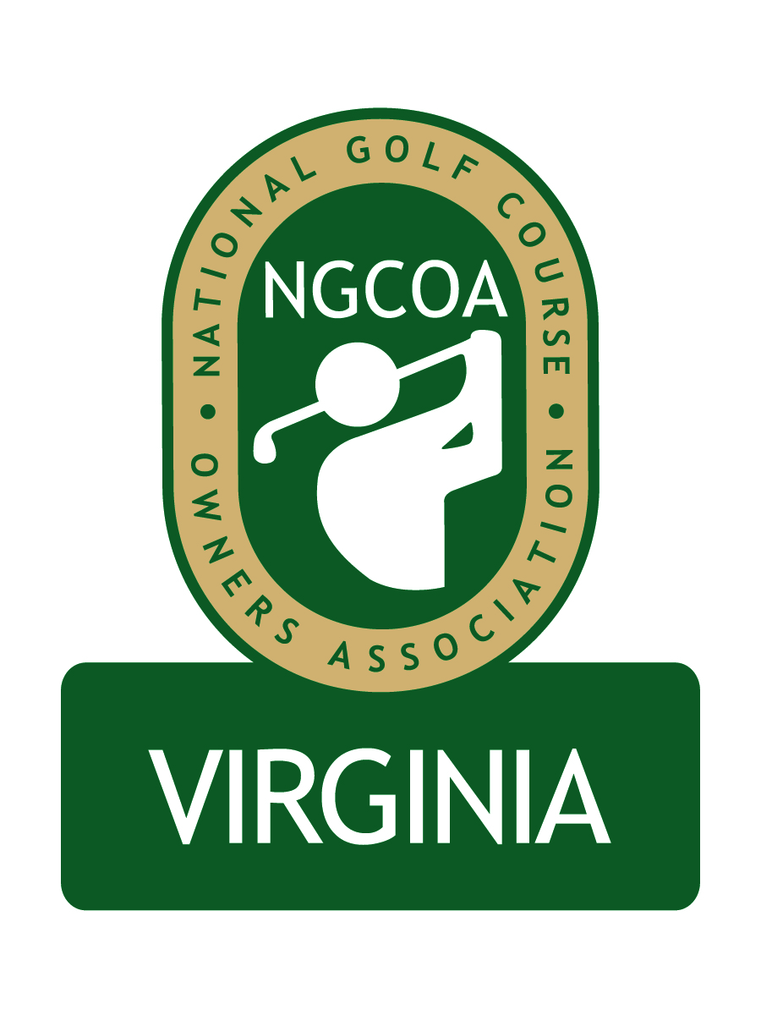

NGCOA Virginia Board Conference Call
Thursday, May 12, 2011

Minutes

Attendance – David Norman, Mike Bennett, Mike Hatch, Rob Waldron, Don Ryder, Nancy Downie, Joe Rice

The meeting was called to order at 1:35 pm.

Roll Call of Participants

The meeting began with a roll call of participants.

Approval of Minutes

The minutes of the April meeting were approved.

Treasurer’s Report

Norman gave the Treasurer’s report, which was approved.

Board Nominee

Bennett asked Norman to provide background on the nominee to the board, Mike Fentress of Virginia Beach Golf Management. Fentress is a partner with Virginia Beach Golf Management, which recently established a long-term lease with the city of Virginia Beach to operate three courses, Bow Creek, Kempsville Greens and Red Wing Lake. A discussion ensued with positive comments about Mr. Fentress. There was not a quorum, so Norman said he would circulate a motion for approval of the appointment to the Board.

Corporate Partner Policy

Norman reviewed Golf Rodeo’s interest in becoming a NGCOA VA Corporate Partner. Golf Rodeo is a third party reseller of tee times. Most parties preferred not to have corporate partners in this category. Rice was asked about the national policy, and they are approved to exhibit at the show or advertise in the magazine, but they are not approved to be partners. Waldron indicated there are “gray areas,” citing EZ Links and Golf Now. Rice mentioned that exclusivity in a category implies endorsement. Waldron suggested we adopt a policy similar to the national one. Rice said he would supply a copy of that policy.
Membership & Partner Program Update

Paid members over the past month are Rock Harbour, Birdwood and The Pines at Ft. Eustis. Downie’s calls to renewing clubs and prospects have been optimistic. In addition, we are soliciting Visage as a partner.

Member Services – Electronic Newsletter

An electronic newsletter has launched. The board asked Norman to monitor the statistics on viewing.

2011 Events – CMAA Joint Meeting, US Senior Amateur

The joint meeting with the Virginias Chapter of CMAA is set for June 20th at the Country Club of Virginia. The event will feature a presentation on social media, as well as legal and tax implications. There will also be a leadership roundtable with Norman leading the discussion. The event will also include a golf outing.

Norman also noted that the USGA Senior Amateur Championship will be contested at Kinloch GC in September, which should be an opportunity to promote golf in Virginia.

Management Agreement

Bennett presented the draft of the management agreement with Norman & Associates for review by the board. Waldron asked if we were still considering a possible regional expansion to include Maryland, and Norman responded that national did not want to pursue this at this time. The board went into executive session for discussion.

Adjournment

The meeting was adjourned at 2:30 pm. Subsequently a conference call presented by Mike Tinkey on “Third Party Resellers” ensued.

