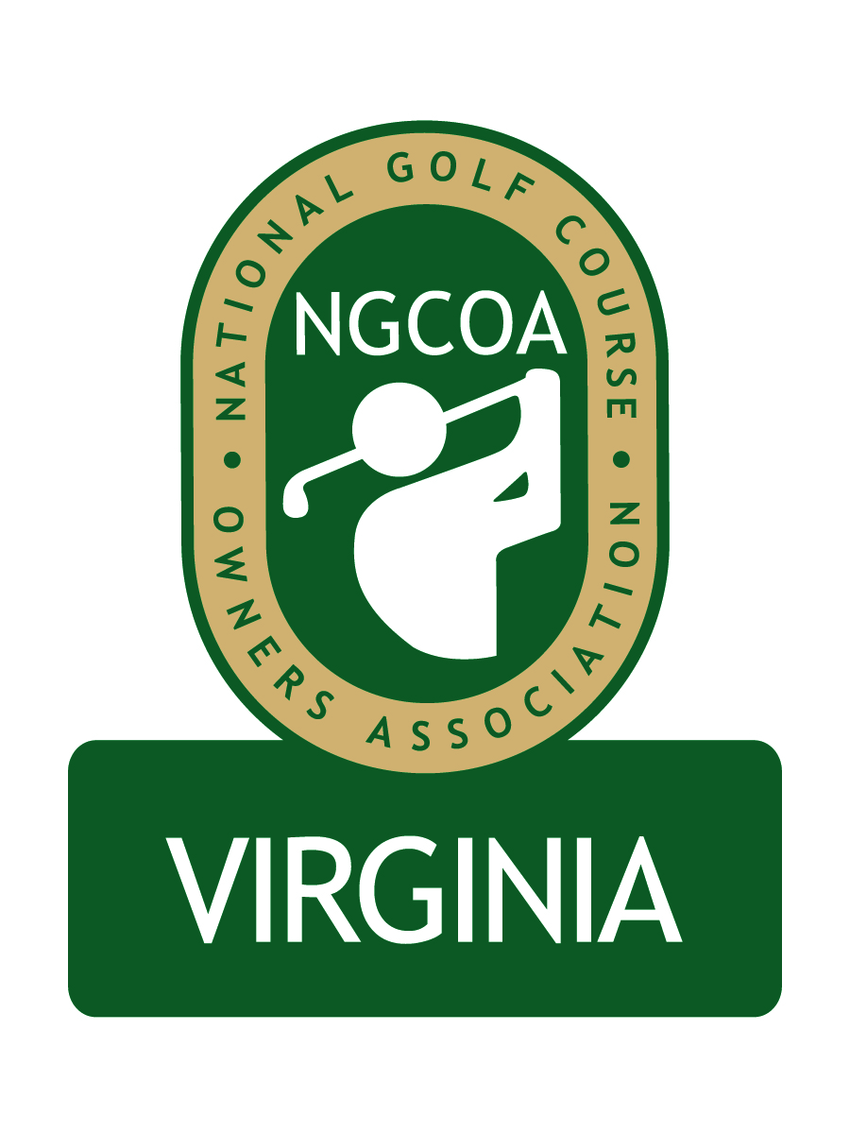

NGCOA Virginia Board Conference Call
May 21, 2013

Minutes

Attendance – David Norman, Mike Bennett, Mike Hatch, Bob Swiger, Mike Cutler

The meeting was called to order at 2:03 pm.

Roll Call of Participants

The meeting began with a roll call of participants.

Approval of Minutes

The minutes of the previous meeting were approved.

Treasurer’s Report

Norman gave the Treasurer’s report, which was approved.

Report from National Office

Norman presented a summary of the news dues structure proposed by national. The changes are not major, and it has been a long time since they have increased. Hatch explained that from a budget standpoint, NGCOA has a goal that dues represent 25% of total income.

2013 Events

The group reviewed the webinar series to date, including a program on growing women’s golf and a review of how new health care regulations will affect our industry. It was suggested to post the health care webinar on the website for post-event review. The next webinar will be on member retention.

The joint meeting of NGCOA VA, CMAA and VGCSA is set for Monday, June 10th at Princess Anne CC. Former Augusta National superintendent Billy Fuller will speak on master planning and renovation.

The NGCOA VA Annual Meeting is set for Wednesday, September 25th at Ford’s Colony CC in Williamsburg. The group reviewed a new concept for our Annual Meeting, featuring an annual awards program with presenting sponsors. Initially there will be four awards: membership campaign (private club), marketing program (public course), environmental stewardship (any club) and a service award (an individual). Waste Management was suggested as a possible sponsor of the environmental award.
Partner Program

Norman reported that there are 10 partners up for renewal in the next five months, totaling $7,000 in sponsorship if renewed at the same level.

Government Relations Update

Norman reminded that the Virginia DCR has approved $100,000 in grants available to nutrient management planners. These grants may cover around half of the cost of the plan. All golf courses in Virginia will be required to have a certified nutrient management plan in place by July, 2017.

Old Business / New Business

The VSGA has requested that NGCOA VA donate $500 toward the 2013 State Open purse, since they lost their sponsor. There was discussion, and since there were some board members absent from the meeting, it was decided to follow up with an email discussion and vote.

Bennett reminded the group that the deadline for the Virginia Tourism grant program was coming up soon. Tier I provides for a matching grant up to $10,000. At least three entities must partner to qualify for a grant. A reminder will be sent to the membership at large.

The board approved a nomination of Damon DeVito of Affinity Golf Management to join the board. Bennett will contact DeVito to invite him to serve.

The next meeting is scheduled for Tuesday, July 9 at 2 pm.

Adjourn

The meeting was adjourned at 2:48 pm.

