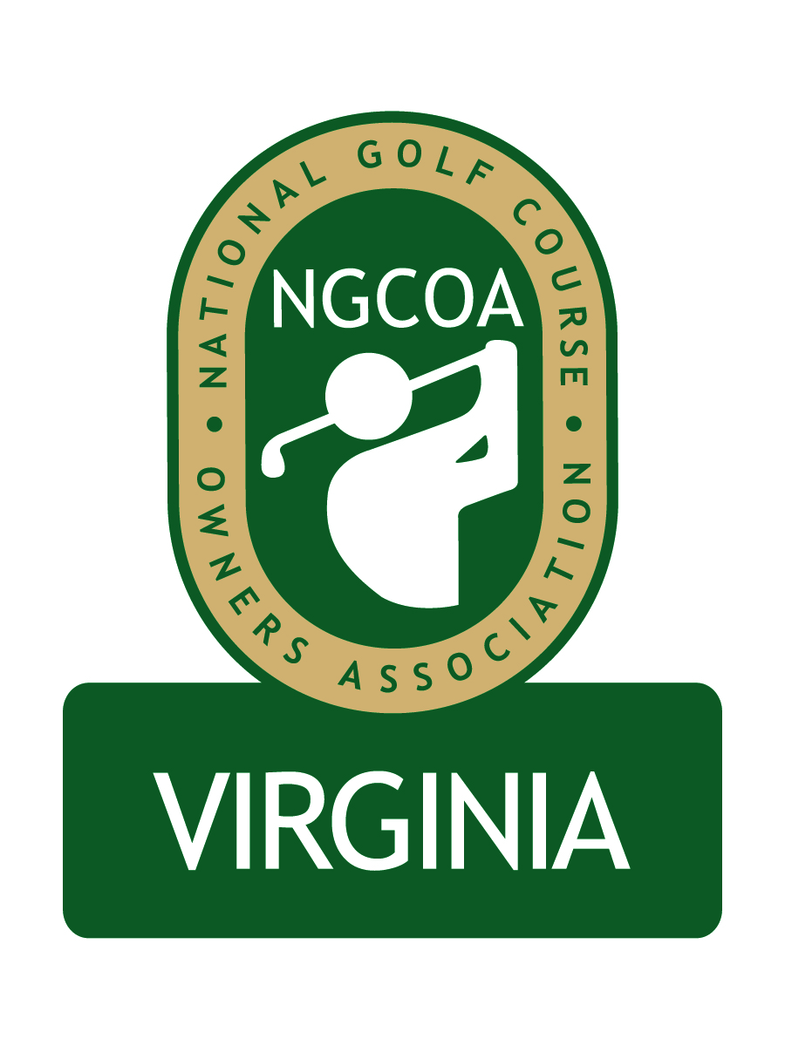

NGCOA Virginia Board Conference Call
May 24, 2012

Minutes

Attendance – David Norman, Mike Bennett, Phil Owenby, Bob Swiger, Glen Byrnes, Don Ryder, Mike Fentress, Rob Waldron, Nancy Downey

The meeting was called to order at 1:32 pm.

Roll Call of Participants

The meeting began with a roll call of participants.

Approval of Minutes

The minutes of the last board conference call were approved.

Treasurer’s Report

Norman gave the Treasurer’s report, which was approved. Bennett asked Norman to do a forecast for the remainder of the year to make sure we are covering our obligations.

Partner Program

Norman gave an update on the Partner program. Solicitation is ongoing, and a prototype newsletter is being developed as an amenity of the program. The design will feature a four-page format, with a separate insert as a “Preferred Vendor/Partner Guide.” We are working on retaining current partners and gaining new ones.

Update from National

Downey reported that member dues revenue is above budget (up 3.5%). Some factors include better contact strategy and better early season weather. NGCOA plans to hire a new person focused on member acquisition. The conference in Las Vegas was rated as the best ever. Upcoming events include the Multi-Course Owner Retreat in June and the 2013 NGCOA Conference in San Diego. Byrnes asked about getting NGCOA VA Partners a subscription to Golf Business, perhaps marked “compliments of NGCOA VA,” as an additional amenity to supporting the chapter. Downey said she would look into this.

Virginia Tourism

There was a call to get more money budgeted to promote golf at Virginia Tourism. It was noted that they have a separate wine office, but the economic impact of the wine industry compared to the golf industry is not even close. Swiger asked if we had any statistics comparing the golf economy and the wine economy, and Byrnes said there is nothing formal. Swiger is seeing the same preferential treatment of the wine industry in Loudoun County.

Virginia Tourism had a meeting to discuss the future of the Virginia Golf Guide publication, but it is likely to remain status quo until they hire a new CEO.

Norman highlighted the marketing leverage program, and Bennett indicated that Traditional Golf Properties received a grant ($5K) – the Williamsburg CVB was the lead partner. They require it to be a new program.

2012 Events

The NGCOA VA Annual Meeting & Golf Outing is set for September 19th at the newly renovated Augustine Golf Club in Stafford, which is managed by Raspberry Golf Management. The renovation has been very successful, with excellent greens and a conversion to bermudagrass fairways. Speakers are currently being sought for the event. Byrnes suggested a “Golf 2.0” player development presentation, perhaps with Bob Baldassari and/or John Guhl.

Old/New Business

Bennett mentioned that Bernice Dowell (who spoke at our 2010 meeting) is reviewing property taxes for Traditional Golf Properties facilities and has saved around 30% for them. She works on a contingency basis and works with agents directly. Swiger then mentioned that a small private club in Loudoun Co. had a big increase in property taxes due to the “income only” approach used by the assessor – he cautioned the group about this. Bennett said James River Co. values golf courses on a per-hole basis with a clubhouse value added in. Bennett also mentioned that each county has a “reevaluation period” which you must hit to gain consideration.

The next board conference call was set for 1:30 pm, Thursday, June 21.

Adjournment

The meeting was adjourned at 2:25 pm.

