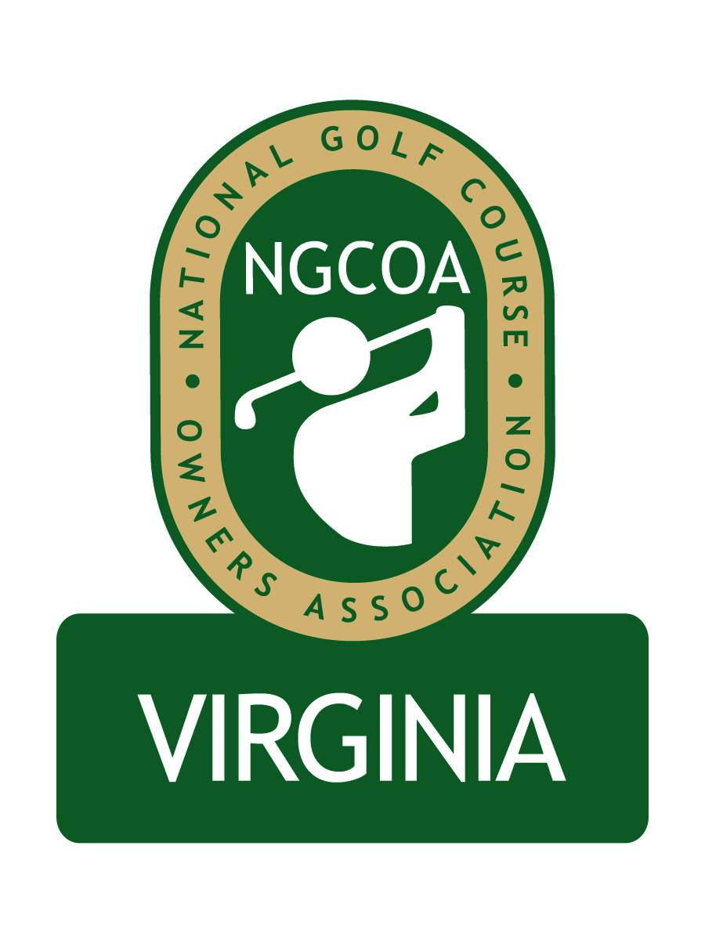
NGCOA Virginia Board Conference Call
June 21, 2012

Minutes

Attendance – David Norman, Mike Bennett, Bob Swiger, Glen Byrnes, Don Ryder, Rob Waldron, Mike Hatch

The meeting was called to order at 1:32 pm.

Roll Call of Participants

The meeting began with a roll call of participants.

Approval of Minutes

The minutes of the last board conference call were approved.

Treasurer’s Report

Norman gave the Treasurer’s report, which was approved.

Update from National

Nancy Downie was unable to attend the meeting but provided the following update. A new person is being hired to focus on member acquisition. Membership renewals are going well. A webinar on the new rules for “Narrow Banding” (i.e., new FCC regulations affecting handheld walkie talkies) was well done and is now available for playback online. National has added a subscription for NGCOA VA Partner, as requested by Byrnes. Byrnes suggested that Norman coordinate a letter to solicit membership through Joe Rice.

2012 Events

Plans for the 2012 Annual Meeting at Augustine GC on September 19th were discussed. Grant Grayson of Leclair Ryan will be one of the speakers. Bennett suggested that we want the presentation to be positive (i.e., how to help owners), as opposed to focusing on problems – this could include financial advice.

Immediately following the board call, a “Golf 2.0” webinar was scheduled. Norman mentioned that Cybergolf had offered to do a webinar in July. The topic would be “Mobile websites and Text Marketing.” A future topic could be Cybergolf’s GolfRev program (i.e., daily deals), and Bennett suggested that this would be an interesting topic for the daily fee courses.

Hatch suggested that we need a long-term strategy for the association – we need to grow first and focus on “low hanging fruit.”

Partner Program

Norman gave an update on the Partner program. We are working on retaining current partners and gaining new ones, and he requested the assistance of the board. The first edition of the printed newsletter will feature a Partner Guide. Mike Bennett suggested promoting the Listserve and webinars as member amenities. Byrnes suggested posting the newsletter on the website.

Old/New Business

The Strategic Planning Meeting was discussed. Hatch (as a national board member) reported that NGCOA has a good face-to-face meeting to discuss goals, communication, and growth versus status quo. Should we set up a task force? He acknowledged the need for sponsorships. Various sites for the meeting were suggested, and the group decided to see if Kinloch would be available to host in August. In the interim, the group decided that it would be fine to schedule another webinar before the meeting.

The board asked Norman to poll them to determine the date of the Strategic Planning Meeting.

Adjournment

The meeting was adjourned at 2:23 pm.

