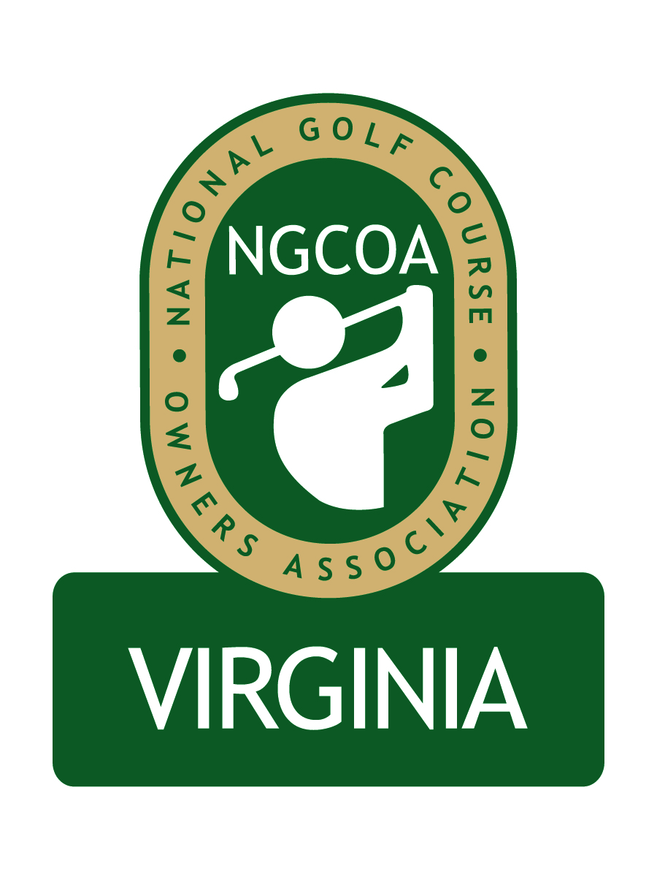

NGCOA Virginia Board Conference Call
Thursday, July 21, 2011

Minutes

Attendance – David Norman, Mike Bennett, Mike Hatch, Rob Waldron, Phil Owenby, Bob Swiger, Andy Weissinger, Nancy Downie

The meeting was called to order at 1:32 pm.

Roll Call of Participants

The meeting began with a roll call of participants.

Approval of Minutes

The minutes of the May meeting were approved.

Treasurer’s Report

Norman gave the Treasurer’s report, which was approved. Bennett outlined the need to develop ongoing revenue sources to establish independence for the chapter. He indicated that we need to do so in the next 45 days to create the plan, and noted that the national office has been very supportive and that we cannot go back to ask for more support. He would like to have a special committee on sponsorship, with a goal for committee members to get the best 10-15 leads and to make 4-5 calls per month. He noted that the annual meeting should provide a good opportunity to generate sponsorships. He asked that a meeting be arranged to discuss the revenue planning.

General Counsel Proposal

The Board considered the proposal from Grant Grayson of LeClair Ryan to become NGCOA VA General Counsel. Their offer is pro bono for basic services. The firm has done considerable work for Virginia golf course clients. Bennett recommended Grayson. Owenby knows them well and has a high opinion. The motion to approve Grayson as new Counsel passed.

Membership & Partner Program Update

Norman announced that Salisbury CC is joining. Downie reviewed the online renewal service, which should make it easier for clubs to renew their membership. The subject of multi-course owner clubs was discussed. For MCO’s of 11 or more clubs, national does not collect any chapter dues. Bennett asked Rice to get additional details on the MCO dues policy, so the Board can be better informed on how to handle this.
On the Partner Program, Norman mentioned that recent partners include TerraVea, Environmental Solutions Consulting and Western Golf Properties. There are three companies that have verbally committed to becoming partners but have not paid: CeSafety, Srixon/Cleveland and Fore! Reservations. He also mentioned that Brian Fisher of BSI Agency had contacted us about partnership. Swiger has Raspberry Golf Management’s insurance with them. Swiger also announced that RGM would be coming on as a Silver Partner. Additional prospects include Visage (Club Car unit), Links publications and turf companies.

Event Updates

The joint meeting with CMAA was very good, with around 45 attendees and a good discussion on social media and a roundtable exercise, followed by golf at The Country Club of Virginia.

At the Virginia Golf Council meeting, there was an update on the Virginia GCSA’s “Best Management Practices” project, which is on schedule. Additional VGT topics included the Virginia Golf Trail (growing but still absent of major resorts), H2B (hourly wage proposed to go up $2/hour), regulatory issues (passing of environmental stewardship legislation supported by the golf industry), a new Economic Impact Study (VGC organizations to contribute – cost reduced) and a new VGC column in Virginia Golfer magazine.

Annual Meeting

The NGCOA VA Annual Meeting is set for Monday, October 17th at Hermitage CC. Hatch recommended that a food supplier could help with lunch or showcase products. A possible table top trade show or on-course product display was discussed.

Old / New Business

Bennett asked Norman if we had a report from the Virginia Turfgrass Council on possible involvement with the 2012 conference. Norman will check with Tom Tracy and report back. Bennett also suggested that we should stay involved with Virginia Tourism and get them involved with our annual meeting (invite them as our guest, perhaps also the Lt. Governor).

Adjournment

The meeting was adjourned at 2:25 pm. The webinar on “Mobile Text Marketing” followed the meeting.

