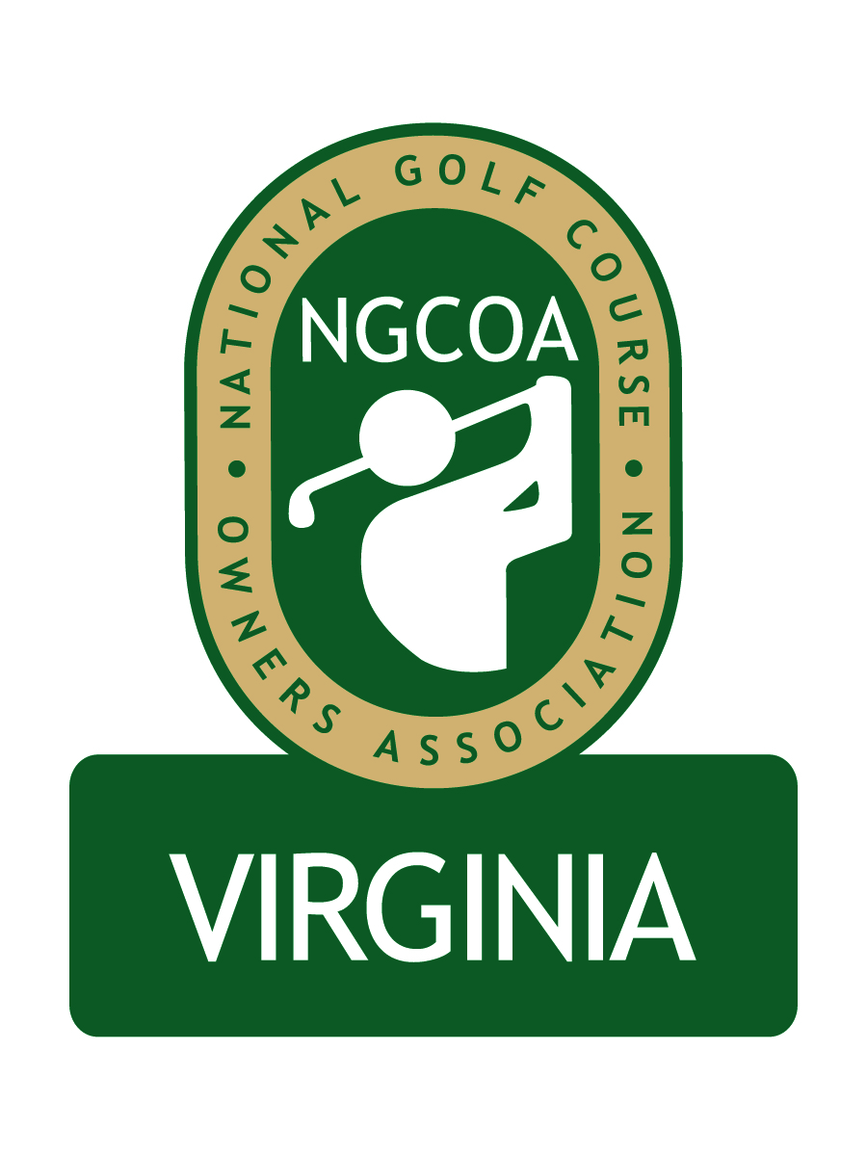

NGCOA Virginia Board Conference Call
August 20, 2013

Minutes

Attendance – David Norman, Mike Bennett, Damon DeVito, Glen Byrnes, Mike Hatch, Phil Owenby

The meeting was called to order at 2:03 pm.

Roll Call of Participants

The meeting began with a roll call of participants.

Approval of Minutes

The minutes of the previous meeting were approved.

Treasurer’s Report

Norman gave the Treasurer’s report, which was approved.

Report from National Office

There was no report.

Partner Program Update

Norman reported that Traditional Golf Properties has agreed to renew its Silver sponsorship, and thus far all 2012 partners have renewed except Western Golf Properties, which has reduced its presence in Virginia.

Webinar Education

Norman reported on the webinar program, which included the following programs: “Connecting with Her” by Mike Aldrich, “Sales and Marketing Strategies to Get or Keep Members or Golfers” by Jeff Fleishman, “The Changing Technology Landscape – Golf Now & Fore!” by Pellucid, “What Do Golfers Really Want?” by Mike Aldrich, “Junior Golf & Family Time” by Mike Aldrich, “Moving Past the Headache – An Update on Healthcare Reform” by Steve Northrup. Norman also mentioned the use of the Start Meeting software platform, which is very affordable and includes posting of webinars for subsequent review by members.

NGCOA VA Annual Meeting Preview

The NGCOA VA Annual Meeting is set for Wednesday, September 25th at Ford’s Colony CC in Williamsburg. Mike Tinkey, NGCOA Deputy CEO, will be the keynote speaker. DeVito noted that it has been tough to budget, as we have been unable to gain sponsorship of the awards program. We currently have a “casting call” to seek nominations for the three awards, which will be voted on by the board. We decided to hold off on the “Green” award (environmental stewardship). A discussion ensued on worthy candidates for the Virginia Golf Leader Award.

Regional Expansion

The regional expansion to a Mid-Atlantic Chapter was briefly discussed, and it was suggested to continue the discussion after the Annual Meeting.

Old Business / New Business

Norman reported that the Virginia Golf Council has approved to commission SRI (in partnership with the World Golf Foundation) to do a new Economic Impact Study on the Virginia golf industry this fall. The last one was based on 2005 data. Bennett reported that our share of the cost will be around $1,700, and it will not be due until 2014. The date of the next board conference call was set for October 3rd at 2 pm.

Adjourn

The meeting was adjourned at 2:37 pm.

