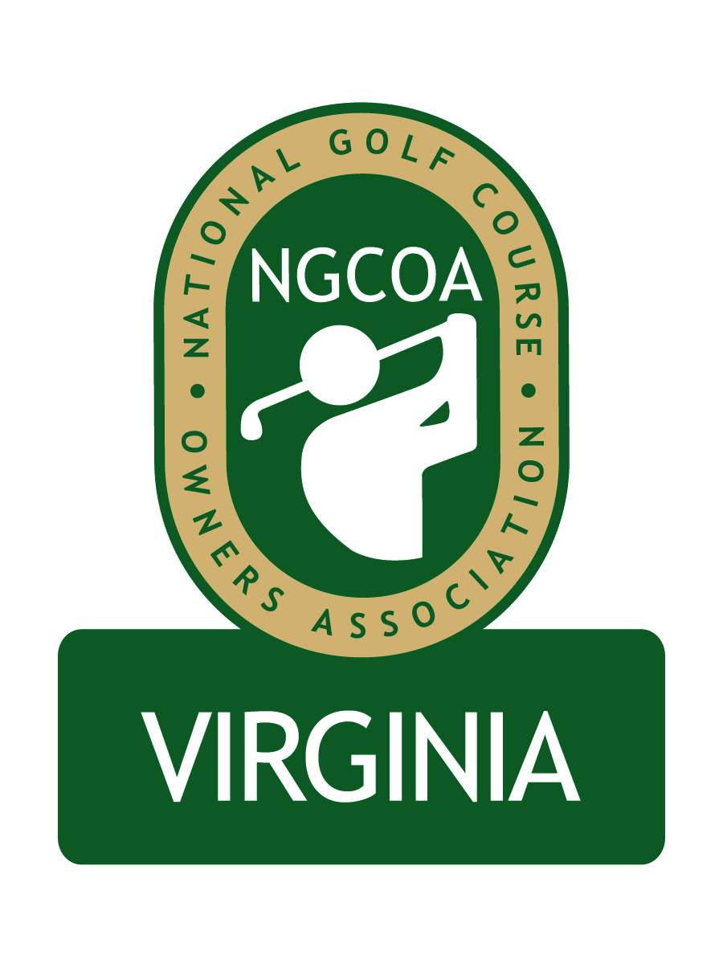
NGCOA Virginia Board Conference Call
Thursday, September 3, 2009

Minutes

Attendance – Glen Byrnes, Richard Cromwell, Dave Donofrio, Bob Swiger, Nancy Downie, David Norman, Mike Cutler, Don Ryder, Mike Bennett

The meeting was called to order at 1:34 pm.

Roll Call of Participants

The meeting began with a roll call of participants.

Approval of Minutes

A motion (Bennett/Cromwell) to approve the minutes of the July 23, 2009 Board Conference Call passed.

Annual Event

Norman reported on plans for the NGCOA VA annual meeting at The Country Club of Virginia on Monday, September 28, 2009. A professionally printed brochure has been distributed to the invitation list, with periodic blast emails also promoting the event. Currently there are just a few entrants, since the invitations have not been out long. Norman asked Board members to please respond with their registration. Norman reported on the program, highlighting Mike Hughes’ address on the state of the industry, along with the panel presentation by Glen Byrnes, Bob Swiger and Richard Cromwell. The topics will be “customer service”, “forming alliances to maximize business”, and “Ideas – Where do they come from?” Norman also noted that Rutledge Baker of the national NGCOA office has offered an additional sponsorship of $2,300 of behalf of the industry partners. We will feature their signage, and the sponsorship includes the continental breakfast on behalf of Toro distributor Smith Turf & Irrigation. Downie indicated that she will be promoting the event in her membership calls.

Bylaws, Articles of Incorporation

Norman reported that a Bylaws draft has been submitted to our general counsel, who made a few suggestions, which were incorporated into the revised copy submitted to the Board. These changes included clarification of the name of the organization and increasing the power of the Board and officers in their capacity to act. Bennett suggested that we review language describing how the Board votes, and Norman said he would review that and follow up with the Board.

Norman also mentioned that general counsel has suggested that the Bylaws be presented for adoption by the members at the annual meeting, and that a full Board and slate of officers also be approved. Accordingly, Norman reviewed the process to select a slate of officers. Through consensus building, the following slate was presented: Mike Bennett, President; Bob Swiger, Vice President; Richard Cromwell, Secretary/Treasurer. A motion was made to approve the slate for presentation to the members (Ryder/Cutler), and it was unanimously approved.

The discussion turned to filling the vacant positions on the Board. Norman said that Vinny Spagnuolo had contacted him earlier in the day about his Board service. Spagnuolo has a new job assignment with the Navy, which puts him in charge of 2,000 employees and 38 programs. Since he is unable to fulfill his duties in the manner in which he would like, he is stepping down from the Board. Norman noted that Spagnuolo is committed to the success of NGCOA VA, and that he had a potential successor for consideration by the Board. The candidate is Gordon Digby, who is program manager for the Navy’s golf division, overseeing 35 golf facilities nationally. He resides in Arlington, and has previously served at US Army golf facilities and in the private sector as a regional manager for KemperSports Management. He is a Class A PGA member and has been in the golf business for 29 years. Following review of Digby’s credentials, the Board requested that Norman contact him to gather more details and to confirm his interest in serving.

Subsequently Norman reviewed the candidates that have been suggested to fill the other open position on the Board as follows: Mike Maloney, GM at Pleasant Valley GC (also overseeing South Riding Club); Mike Hatch of Acumen Golf (managing Brandermill CC and Birkdale GC); Kenny Kerr, GM at The Virginian GC; Phil Owenby, GM at Kinloch GC; and a representative from Farmington CC (suggested by our general counsel). Upon review of the candidates, Cromwell noted that Hatch’s clubs are in a market segment not currently represented (moderate level private club). Downie added that she has spoken with him and was impressed; also mentioning that he is originally from London, England. The Board authorized Norman to contact Hatch to gain further details and to gauge his interest in serving.

Membership Initiative Update

Downie gave an update of the membership initiative. During the summer, the national office has directed a lot of energy towards fighting a proposed recreation tax in North Carolina, and the measure was defeated. Thus she is now able to resume calls on the membership initiative in Virginia. She is promoting the annual meeting on the calls. Membership will also be promoted at the annual meeting itself, since non-members are invited. Downie noted that the NGCOA web site will offer new features on legislative issues, including a new tool that will allow members to easily contact their legislators on matters of importance to them.

Government Relations Update

Downie’s update of the N.C. tax issue was a good segue into the discussion on government relations. Norman mentioned that the H-2B program had reopened the application process for FY 2009. Cromwell clarified that the reason was because clubs did not utilize the full quota of visas that they received approval for. Thus there are around 25,000 visas available from the 66,000 approved by the government.

Norman also gave an update on the proposed regulations on storm water management, which the Virginia DCR is overseeing. The regulations would add to cost of maintenance and new development of golf courses. A consortium of golf and turf organizations is fighting the measure, including the VGCSA, VTC and Virginia Agribusiness Council. The public comment period has just ended, and each organization submitted recommendations, including suggesting that they be represented on the committee to draft the language.

Administrative Update

Norman plans to set up a bank account and accounting systems once incorporation takes place and a tax I.D. number can be obtained.

Old & New Business

Under new business, Byrnes suggested that prior to the annual meeting, we should submit the Bylaws and slate of directors and officers to the attendees for their review in advance. The Board agreed that we should do so. Norman suggested that this could take place once we have finalized the slate.

The Board decided that they want the next meeting to remain in conference call format. The date is October 22, 2009 at 1:30 p.m.

Adjournment

The meeting was adjourned at 2:23 p.m.

