Sustainability Leader – Swan Point Yacht & Country Club

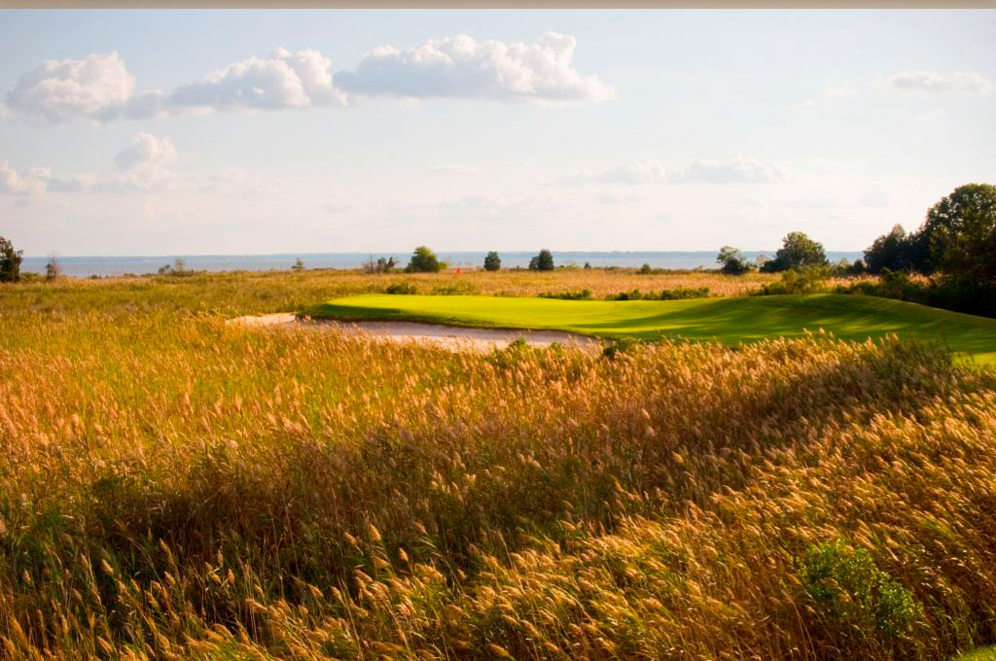
Swan Point is situated adjacent to the Potomac River and the
Cuckhold Creek in southern Maryland

The NGCOA Mid-Atlantic’s newest award is the Sustainability Award, recognizing the ability to incorporate sustainability and environmental stewardship into operating practices. Swan Point Yacht & Country Club is the 2019 honoree, in recognition of their focus on environmental stewardship, while co-existing with nature and wildlife. Dottie Harper, VP of the Swan Point Development Company, accepted the award.

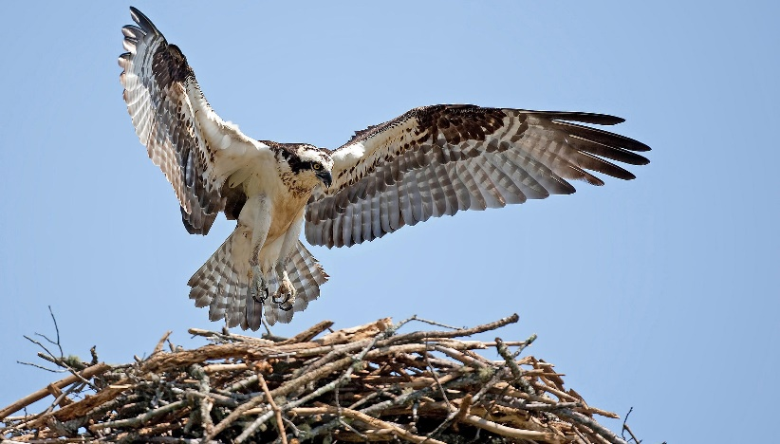

Swan Point is located in southern Maryland, situated adjacent to the Potomac River and the Cuckold Creek, in a beautiful, natural area. “It has a Carolinas feel,” said GM Peter Gardner. “There are large pines, tranquil marsh lands and waterfront vistas.” It is known for abundant wildlife, especially deer, turkeys, foxes and tons of birds – herons, ospreys, hawks and other fowl. This is the setting for a fun and challenging golf course.

The club’s marina is involved in the Chesapeake Bay Oyster Gardening Program. Recently 14,000 oysters were cultivated in local waters, then returned to reefs on the Bay. The club works with the Chesapeake Bay Foundation to get property owners involved in the program. They offer an “Oyster Basket Building Workshop” – oysters serve as a filter for the Bay.

The club is managed by KemperSports, which has a “Green to a Tee” program, focused on environmentally sensitive management of the property. They deliberately limit inputs of fertilizer and pesticide near water features. Environmentally sensitive areas are marked and players are prohibited from entering such areas.

The club’s wedding venue is located Creekside in a beautiful setting, but also one managed with care to nature. They always protect areas near the creek and the river.

“It’s exciting to be recognized, because we are making efforts toward the well-being of our environment,” said Gardner. “We want to be good stewards.”

