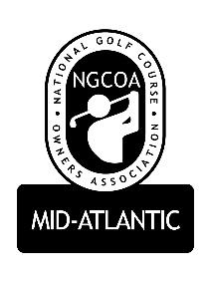

NGCOA Mid-Atlantic Board Conference Call
3:00 pm, Tuesday, November 22, 2016
Mike Bennett, Mike Fentress, Don Ryder, Joe Hills, Rick Rounsaville, Mike Hatch, Bob Swiger, Damon Devito, David Norman, Glen Byrnes
- Call to Order: Mike Bennett – 3:04
- Approval of Minutes - Mike Bennett Motion, Rick Rounsaville 2nd.
- Treasurer’s Report David Norman gives an overview of Budget – Motion – Mike Hatch, Mike Fentress 2nd
- Annual Meeting Recap – Overall consensus, it was a great meeting.
  - MB thought meeting was good but felt a little crammed and suggested maybe adjusting the schedule.
  - DD suggests the awards 1st and not speech, smile, thank you, picture, cut down intros.
  - Mike Hatch noted Jay Karen was impressed by the event.
- Health Care and Benefits Survey
  - 26 Respondents, various types of clubs responded
  - Distribute to everyone and put on the website with link to results
  - Relay results to National
- Government Relations with National
  - Overtime rule starts Dec. 1st
  - Outlook with New Administration
    - Get VA and MD Trump clubs as members and active
- 2017 Chapter Relationship with National
  - Michigan and Indiana have previously broken away from the traditional National affiliation relationship
  - Administration, Marketing, Accounting
    - DN went over how admin and dues structure, marketing, accounting has changed with National and how it will affect the chapter and how it is run.
    - Motion to have David send over new budget with new management fee structure and there will be another board meeting to discuss
- 2017 Partner Program – we are up this year and have potential to get new partners with change, such as Club Car and Toro.
- Old / New Business
  - Holiday Auction is underway
  - 1757 Club has been offered by Joe Gohlmann for 2017 Annual Meeting
- Adjourn – 4:02

