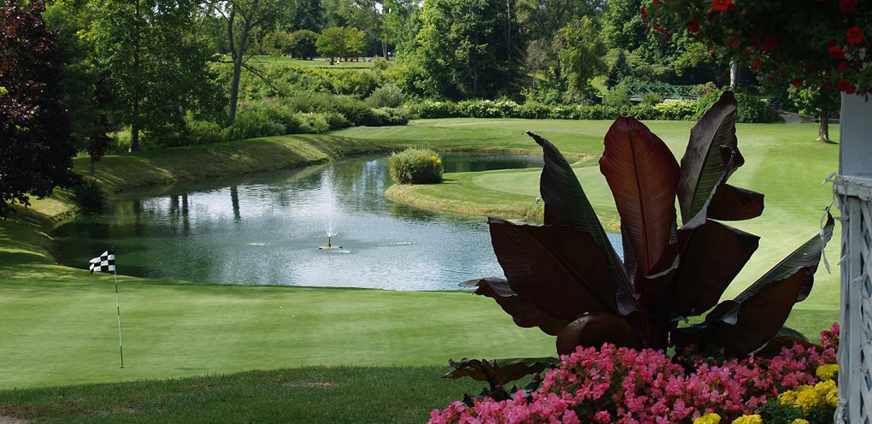
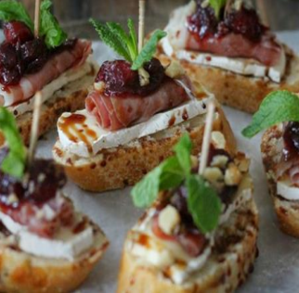
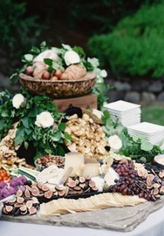
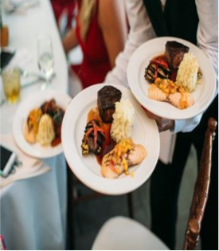
2
0
1
8

LANCASTER COUNTRY CLUB | CATERING MENU

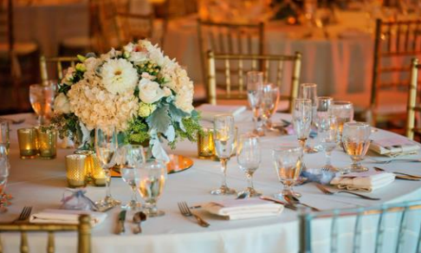

LANCASTER COUNTRY CLUB

Come discover what a first-class country club can offer; great golf, & elegant surroundings with all of the amenities you have come to expect and more

Located in Lancaster, New York, Lancaster Country Club was established in 1925 and has
served as host to many prestigious events. Our golf
course spreads over approximately 200 acres and is described
as a traditional layout with subtle elevation change, mature tree lined fairways and small to
medium sized greens

6061 Broadway | Lancaster | New York | 14086
Visit Our Web Site @ www.LCCNY.com
Jocelyn Kowalczyk | Director of Sales
Phone: 716. 684.3700 ext. 13
E-Mail: SalesLCCNY@gmail.com

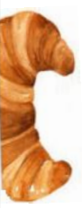

Continental Breakfast
Assorted Fresh Juices, Coffee and Tea
Assorted Petite Breakfast Pastries and Muffins, Bagels, Butter, Fruit Preserves, Cream Cheese
$9 pp

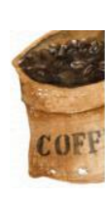
The Basic Breakfast Buffet
Assorted Fresh Juices, Coffee and Tea
Fresh Seasonal Cut Fruits, Assorted Petite Breakfast Pastries and Muffins, Bagels, Butter, Fruit Preserves, Cream Cheese,
Scrambled Eggs, Home Fries with Sweet Onion & Green Peppers,
Smoked Bacon & Country Sausage Links
$17 pp

. . . .

Brunch Buffet
(Minimum of 25 people)

Includes Assorted Juices,
Fresh Cut Fruit, Muffins and Pastries, Scrambled Eggs
Home Fries or Roasted Potato
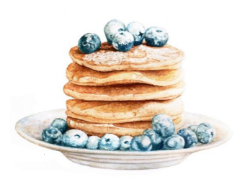
Crispy Bacon or Savory Sausage
Herb Grilled Chicken
Seasonal Vegetable
Coffee/Tea Service
$20 pp

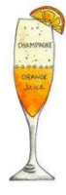
Brunch Buffet Enhancements
(Priced per person)

Eggs Benedict $4
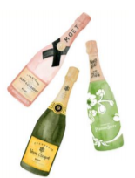
Sautéed Spinach $2
Smoked Salmon with Traditional Garnishes @ MARKET PRICE
Omelets Station Made to Order $4pp+ $50.00 Chef Fee
. . . .

Call Bar: (per person)
Smirnoff, Gordon’s, Bacardi, Seagram’s 7, Jim Beam, Cutty Sark
Choice of (2) Domestic Bottled Beers & (1) Imported Bottled Beer Selection
Includes House Wines, Soft Drinks & Juices
One Hour $9
Two Hours $16
Three Hours $22
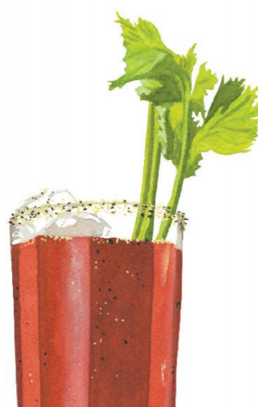
Four Hours $28
. . . .
Beer, Wine, & Soda Service: (per person)
Includes Bottled Beer, House Wine, Soft Drinks & Juices
One Hour $7
Two Hours $12
Three Hours $16
Four Hours $20
. . . .

Punches: (Prices are per Gallon, 2 gallon minimum)
Fruit $27
Wine $37
Mimosa $47
Margarita $47
Bloody Mary $47

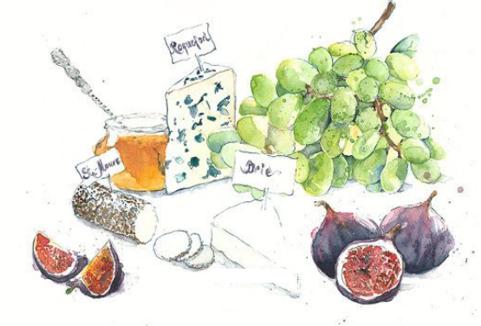
(priced per person)

Cheese, Fruit & Vegetable Display $ 9
Imported & Domestic Cheeses, Seasonal Fruits & Berries, Assortment
of fresh Vegetables, Chutney, Gourmet Crackers and Flat Breads

Antipasto Display $ 12
Capicola, Genoa Salami, Prosciutto, Fresh Mozzarella,
and Aged Provolone Cheeses, Roasted Peppers,
Cured Olives, Olive Oil, Ciabatta Bread

Seafood Display $ Market Price
Raw Oysters & Clams, Steamed Crab Claws, Shrimp Cocktail,
Shrimp Ceviche, and appropriate accoutrements

Mediterranean Display $ 9
Olives Tapenade, Flavored Hummus, Peppers with Roasted Garlic,
Baba ghanoush, Couscous, Marinated Artichoke Hearts, Warm Pita

Far East Display $ 10
Spring Rolls, Chicken Satay, Crab Rangoon, BBQ Ribs,
Pork Pot Stickers, & Sweet and Sour Sauce

Coffee & Dessert Display $ 8
Regular and decaffeinated Coffee, a selection of International Teas
and Chef’s assorted pastries.

Deluxe Coffee Bar $ 10
Regular and decaffeinated Coffee, a selection of International Teas,
Hot Cocoa, flavored syrups, shaved chocolate, cinnamon sticks,
whipped cream, and an assortment of Chef’s pastries.

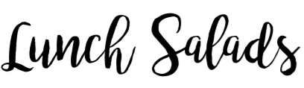

Includes Soup Du Jour, Warm Roll Service, Choice of Dessert, Coffee & Tea Service
Greek Salad
Romaine Lettuce Tossed with Greek Dressing, Bell Pepper, Kalamata Olives, Marinated Feta, Onions
$15

Strawberry Salad
Spring Mix Salad, Candied Walnuts, Goat Cheese, Fresh Strawberries
$15
Caesar
Romaine Lettuce Tossed with Our Homemade Caesar Salad Dressing, Croutons & Shaved Parmesan Cheese
$15

The Wedge
Baby Iceberg Quartered Salad, Onion, Bacon, Bleu Cheese, Tomatoes
$15

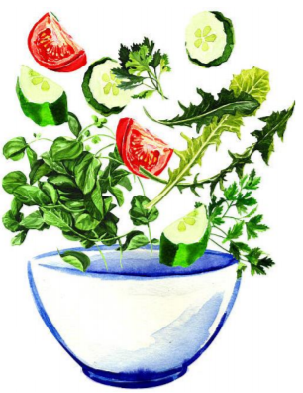
Salad Additions:
Grilled Chicken $4
Grilled Salmon $8
Grilled Shrimp $8
Seared Ahi Tuna $10
Sliced Steak $10

Choice of Dessert:
Canolli, Chocolate Mousse,
Assorted Old Fashioned
Cookies & Brownies Plated

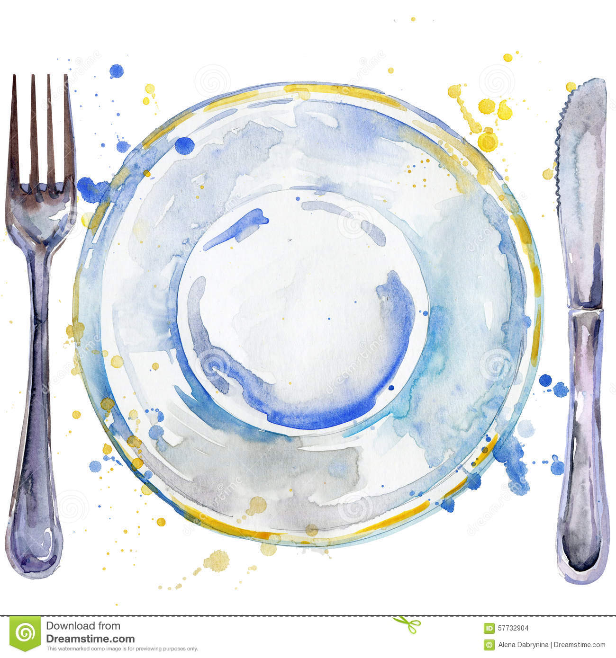

Select TWO Entrees

Includes Choice of:
House Salad or Caesar Salad
Starch & Vegetable

Served with Freshly Baked Rolls & Butter

Chicken Piccata 19
Sautéed and finished with a Light Lemon Caper Sauce

Chicken Marsala 19
Sautéed Breast of Chicken, Mushrooms and Shallots in Marsala pan sauce

Grilled Salmon 20
Choice of Herbed or Horseradish Crusted Salmon Fillet

Haddock 17
Bruschetta Topped Broiled Fillet of Atlantic Haddock

Bistro Tenderloin 20
Grilled Bistro Tender with a red wine Demi-Glace

Strip Steak 20
Grilled 8 oz center cut Strip Steak served with sautéed mushrooms

Pork Tenderloin 18
Thyme Mustard Crusted Pork Tenderloin

Coffee and Tea Service

Choice of Dessert:
Canolli, Chocolate Mousse or Assorted Old Fashioned Cookies & Brownies

(25 person minimum)

Lancaster Cook Out
Tossed Salad with Two Dressings
Grilled Chicken Breast
Macaroni Salad & Potato Salad
Hamburgers and Hot Dogs with
Assorted Rolls and Condiments
Brownies and Assorted Old Fashion Cookies

(Add…)
Choice of Italian or Polish Sausage $3 pp
$18

Par 3 Buffet
Fresh warm Rolls with Butter
House Salad or Caesar Salad
Herb Roasted Cicken
Roasted Top Round of Beef
Roasted Red or Mashed Potatoes
Seasonal Vegetables
Choice of
Chocolate Mousse
or Strawberry Shortcake
Coffee and Tea Service
$20

The Lancaster Lunch Buffet
Fresh baked Rolls with Butter
House Salad, Caesar Salad
Chicken Picatta or Chicken Marsala
Roasted Top Round of Beef, seasonal vegetables
Roasted Red Potatoes or Mashed Potatoes
Baked Ziti Bolognase
Chocolate Mousse or Strawberry Shortcake
Coffee and Tea Service
$24

(priced per piece)

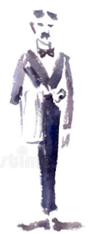
From The Garden & Pastry
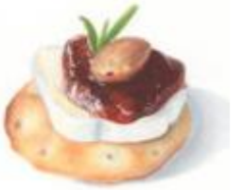
Southwestern Vegetable Quesadillas with Sour Cream & Salsa $2.00
Spanakopita - Spinach & Feta $2.00
Bruschetta served on Toasted Baguette $2.00
Fried Vegetable Spring Roll with a Sweet Chili Sauce $2.00
Brie & Raspberry on crostini $2.25
Cucumber Rounds topped with Hummus $2.00
Caprese Skewers - Grape Tomato, Cherry Mozzarella, & Basil Oil $2.00

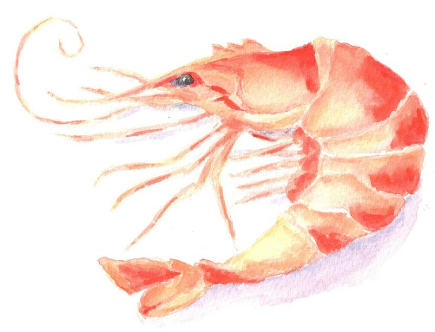
From the Sea
Crab Stuffed Mushrooms $2.50
Shrimp Cocktail $3.00
Bacon Wrapped Scallop $3.00
Petite Crab Cakes with Cajun Remoulade $3.50
Crab Rangoon $3.50

From the Land
Lamb Lollipops served with mint chimi cherr $3.00
Italian Sausage Stuffed Mushrooms $2.25
Chicken Satay $2.50
Chicken Quesadillas with Avocado Cream $3.00
Steak & Cheese Flatbread Squares $3.00
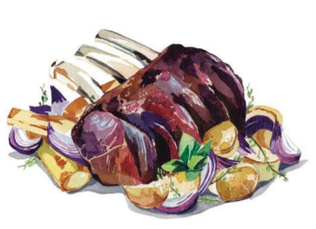
Mini Beef Wellington $3.00

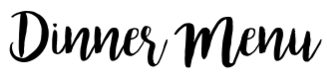
Choose (2) - Plated Dinner Selections Include Choice Of:
House or Caesar Salad,
Starch & Vegetable

Served with Fresh Baked Rolls with Butter

Filet Mignon of Beef - Grilled 6oz Filet Mignon 39

New York Strip Steak - Grilled 12oz Strip Steak with Sautéed Mushrooms 33

Grilled Salmon - Horseradish or Herb Crusted Salmon 28

Sea Bass - Chilean Sea Bass with Tomatoes and capers 40

Chicken Française - Egg, Parmesan and Herb-Battered Chicken Breast, 25
Served with lemon cream sauce

Chicken Marsala - Boneless Chicken Breast, Mushroom, Marsala Sauce 25

Chicken Piccata 25
Sautéed and finished with a Light Lemon Caper Sauce

Pasta Primavera - Spring Vegetables, Garlic, Shallots, White Wine, Penne, 19
Parmesan

Coffee & Tea Service (included)

Choice of Dessert:
Canolli, Chocolate Mousse, Cheese Cake or Plated Assorted Old Fashioned Cookies & Brownies

Dual Entrée
4oz Filet Mignon with Choice of Chicken Dish 32

Children’s Meal (12 + under):
(3) Chicken Fingers Served with French Fries, Carrots, and dip 10

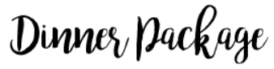

The Ultimate Dinner $ 57

Cheese, Fruit & Vegetable Display
Chef Salad or Caesar Salad
Four Hour Call Bar

Fresh warm Rolls with Butter

(Choice of Two)
Grilled 6oz Filet Mignon
Grilled 12oz Strip Steak
Horseradish or Herb Crusted Salmon
Chicken Francaise, Chicken Piccata or Chicken Marsala

Dual Entrée: Filet & Chicken Add $3 per person

(Choose One)
Roasted Red Potatoes
Garlic Mashed Potatoes

Served with Seasonal Vegetable

Choice of Dessert:
Canolli, Chocolate Mousse, Cheese Cake or Plated Assorted Old Fashioned Cookies & Brownies

Coffee & Tea Service

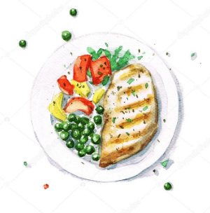
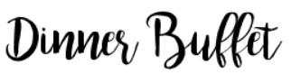

Broadway Buffet $59

Cheese, Fruit, & Vegetable Display
Four Hour Call Bar
Fresh warm Rolls with Butter

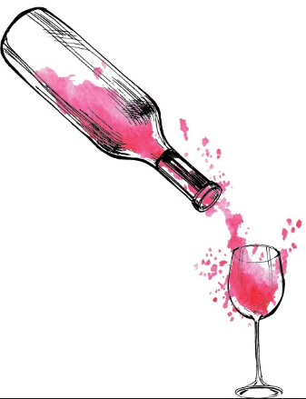
Chef Salad or Caesar Salad

(Choice of Two)
Sliced Beef Top Round
Chicken Marsala
Chicken Piccata
Baked Ziti Bolognese
Herb Crusted Salmon served with Dill Sauce

(Choice of Two)
Rice Pilaf
Roasted Red Potatoes
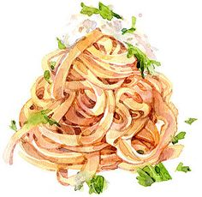
Garlic Mashed Potatoes
Seasonal Vegetables
Roasted Sweet Potato

Choice of Dessert:
Canolli, Chocolate Mousse, Cheese Cake or
Plated Assorted
Old Fashioned Cookies & Brownies

Coffee and Tea Service

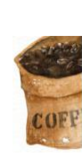

Coffee Station
Freshly Brewed Coffee & Assorted Herbal Teas
$4 per Person

Deluxe Coffee Station
Freshly Brewed Coffee & Tea Assorted
Flavored Syrups, Chocolate Shavings,
Fresh Whipped Cream
$6 per Person

Assorted Petite Pastry Station
Served with Coffee & Assorted Herbal Teas
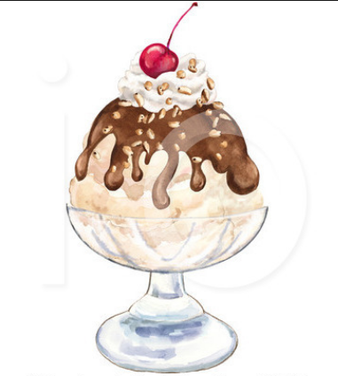
$8 per Person

Deluxe Sundae Bar
Coffee & Assorted Herbal Teas
Vanilla & Chocolate Ice Cream,
Hot Fudge, Caramel Sauce,
Whipped Cream, Fresh Berries, Nuts,
Chopped Candy Bars
$8 per Person

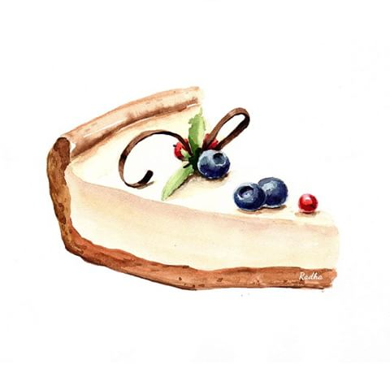
(Additional $50 chef fee to have Station Attended)

Cheesecake Bar
Strawberry, Blueberry, Salted Carmel, Mixed Berry,
Fresh Whipped Cream
$8 Per Person

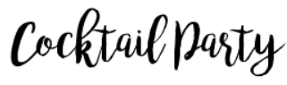

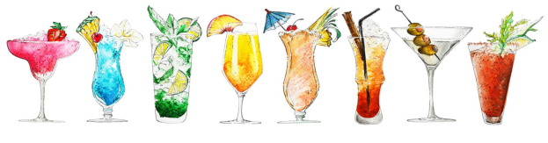

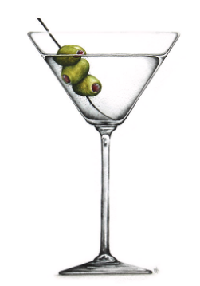
(minimum of 25 people)

Let’s Party $45 per person
Includes Three Hours of Beer & Wine

First Hour:
Assorted Cheeses and Vegetable Display,
Stationed Stuffed Mushrooms, Bruschetta, Chicken Quesadillas

Second Hour
House Salad or Caesar Salad
Sliced Top Round of Beef and Sliced Roast Turkey
With Rolls & Assorted Condiments
Baked Ziti or Pasta Primavera

Third Hour
Coffee, Tea, & Pastry Display

The Ultimate $55 per person
Includes Three Hour Call Bar

First Hour:
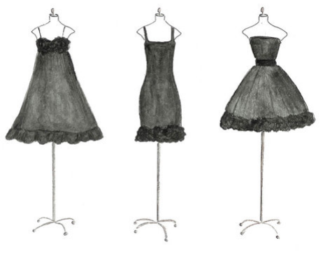
Assorted Cheese and Vegetable Display
Stationed Chicken Satay with Curry Dip
Bruschetta, Mini Beef Wellingtons

Second Hour
House Salad or Caesar Salad
Sliced Roast Beef and Sliced Roast Turkey
Assorted Vegetable Medley
Pasta Action Station: Penne Pasta
with (3) Choices of Sauces
*$50 Chef Fee

Third Hour
Pastry Station with Deluxe Coffee Bar

All Open Bars Consist of Call or Premium Brand Liquors,
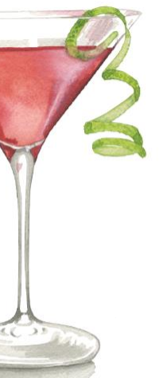
House Wines, Bottled Beer, Assorted Soft Drinks & Juices

Call Bar: (Prices are Per Person)
Premium Bar: (prices are per person)
Stoli, Tanquery, Captain Morgan, Jack Daniels, Makers Mark, Dewar’s

Choice of (2) Domestic Bottle Beers & (1) Import

Wines: Cabernet Sauvignon,
Chardonnay White Zinfandel,
Pinot Noir, Riesling

First Hour $11
Second Hour $20
Third Hour $27
Fourth Hour $34

Smirnoff, Gordon’s, Bacardi, Seagram’s 7, Jim Beam,
Cutty Sark

Choice of (2) Domestic Bottle Beers & (1) Import

Wines Choose Two (2) Brands
Cabernet Sauvignon,
Chardonnay, White Zinfandel

One Hour $9
Two Hours $16
Three Hours $22
Four Hours $28

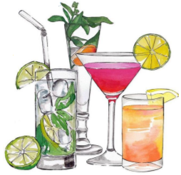

Beer, Wine, & Soda Service: (Prices are Per Person)
One Hour $7
Two Hours $12
Three Hours $16
Four Hours $20

Cash Bar Prices
A $50.00 Bartender Fee will be charged to all Cash Bars
A $50.00 Bartender Fee will be charged to all Consumption and Cash Bars under 30 people

Punches: (Prices are per Gallon, 2 gallon minimum)
Fruit $27
Wine $37
Mimosa $47
Margarita $47
Bloody Mary $47

Champagne $4 per glass

House Wine Service $35 per bottle

Soda, Juice Bar $6 per person

Terms and Conditions

All prices are subject to change to meet our increase in costs.

TAXES AND SERVICE CHARGES

a. MEMBER EVENT:
All food and beverage charges are subject to 8.75% Sales Tax,
11 % gratuity (wait staff), 6% administrative fee (subject to
sales tax).

b. NON-MEMBER EVENT:
All food and beverage charges are subject to 8.75% Sales Tax,
11% gratuity (wait staff,) 9% administrative fee (subject to sales
tax.) Tax exempt organizations must present certificate prior to
payment of function.

The date of your function is not guaranteed until your deposit is paid. Deposits
are based on the size of your party and the room being booked.
Tentative bookings are good for one week. All deposits are non-refundable.
Exact count of guests must be guaranteed at least one week before the function.
This will be the guaranteed amount you will be charged even if fewer guests
attend.
Lancaster Country Club or its employees cannot be held responsible for lost or
left behind articles.

No foods or alcoholic beverages are to be brought in except for approved cake/dessert.
Lancaster Country Club reserves the right to substitute an alternative room if the
original estimate of attendance falls.
Method of acceptable Final Payment – check, money order, cashier’s check, cash, credit card
or member charge.
When payment is in the form of a personal check a credit card is taken to secure
payment.
Please be advised our Dress Code is business casual. (No jeans or sneakers
please.)
The “Serve Safe” policy is followed at Lancaster Country Club.




