APPROVED
The Place at Corkscrew, The Place HOA Master Association, Inc.
EMERGENCY SESSION – HURRICANE IAN
Board of Director’s meeting
When: 10/03/2022 2:00PM
Where: 19900 The Place Blvd., Estero, Florida

Board of Directors
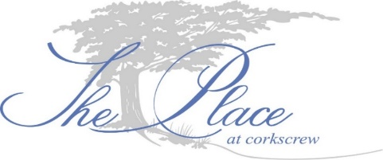
Eileen Barrett (P) Term expires 2024 – In person
Tom Butler (VP) Term expires 2024 – phone
Ed Casey (T) Term expires 2024 – absent
Nick Correll (S) Term expires 2023 – phone
Gary Helwig (D) Term expires 2023 – In person

- Call to order. The meeting was called to order at 2:05PM.
- Establish a quorum. Four of five directors are present either in person or via phone.
- Proof of notice. Emergency meeting called in accordance with F.S. 720.
- Officer’s report. President, Eileen Barrett, reported a Disaster Plan needs to be written. Discussion of items to be added the plan was held. The communication committee is writing a post hurricane update to be blasted. Sunnygrove will cleanup all areas of The Place. Maintenance will photo all broken stop/street signs.
President, Eileen Barrett made the motion to authorize the Safety/Security Committee to create the new domain name for The Place. Director, Gary Helwig seconded the motion. All in favor. Motion passes 4 - 1, with no objections.
- Next BoD Meeting. Currently scheduled for October 10, 2022 at 7:00PM.
- Adjournment. Meeting adjourned at 3:00PM.

Respectfully submitted,
Ron Czarnik, LCAM
For the Board of Directors

