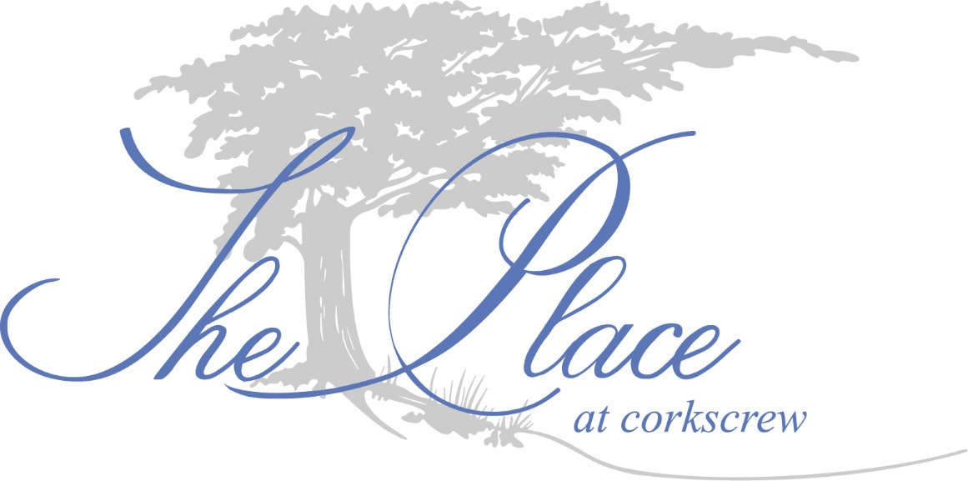

The Place Master Association, Inc.
2018 Budget Meeting
November 8th, 2017

- Meeting called to order at 10:00 AM
- Quorum Established- Nicholas Cameratta and Raymond Blacksmith are present.
- Motion made by Raymond Blacksmith to approve and adopt the 2018 Budget; Seconded by Nicholas Cameratta; all in favor.
- Motion made by Nicholas Cameratta to adopt the Agreement between The Corkscrew Farms Community Development District and The Place Master Association, Inc. for Infrastructure Management and Maintenance Services; Seconded by Raymond Blacksmith; All in favor.
- Motion made by Raymond Blacksmith to adjourn the meeting; Seconded by Nicholas Cameratta; all in favor.
- Meeting adjourned at 10:01 AM

Submitted by Jessica Martin

