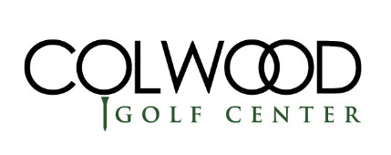 | “3 Club Challenge”  Two Person Best Ball  Sunday, Feb. 6th, 2022  ColwoodGolf.com/3club

FORMAT & PRIZES  Two person teams, 18 Hole event with tee times beginning at 9:00AM at Colwood Golf Center. Best Ball format with Gross and Net prizes awarded to the top finishers.  Every golfer will only be allowed to use 3 clubs for this  event. Club sharing is NOT allowed.  ELIGIBILITY  This event is open to all golfers – official handicaps are not required. However, we ask that all players register for the event by listing one of the following 3 methods for handicapping:  - 1) List your official Ghin handicap index with Ghin #  - 2) List your estimated handicap index  - 3) List your average 18-hole score  IMPORTANT: for the above handicapping methods, please use 18-hole regulation course scoring. Colwood will then convert all handicapping to a par 3 equivalent for the purposes of this event. | ENTRY FEE  Registration is $40 per player ($80 per team).  There are 2 options for registration:  1) Register online at colwoodgolf.com/3club  2) Register in person at the golf shop.  Payment is required at the time of registration.  Refunds are NOT available after February 2nd, 2022  INCLUSIONS  Green Fees, range balls, and 2 drink tickets/per players and prizes are included.  TIES  In the event of a tie, a scorecard playoff will determine the winners (both gross and net).  STARTING TIME  Tee times with begin at 9:00AM.

Register online at ColwoodGolf.com/3club

3 Club Challenge 2022 -- MANUAL REGISTRATION
Player Name _________________________ | Player Name _________________________
Handicap or AVG Score _________________ | Handicap or AVG Score _________________
GHIN # (If applicable) ___________________ | GHIN # (If applicable) ___________________
Daytime Phone # _______________________ | Daytime Phone # _______________________
Street Address _________________________ | Street Address _________________________
City/State/Zip __________________________ | City/State/Zip __________________________
Email Address __________________________ | Email Address __________________________
Player Pairing Request ___________________ | Player Pairing Request ___________________

Make checks payable to “Colwood Golf Center”.
Colwood Golf Center – 7313 NE Columbia Blvd. – Portland, OR 97218
Contact Marketing & Sales Manager, Jarred Gomez at (503)254-5515 or jgomez@kempersports.com with any questions or if you’re a single player in need of a teammate.

