Colwood Golf Leagues 2019
Registration Form – Free to Join!
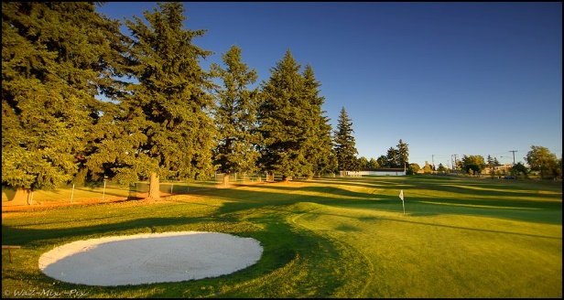
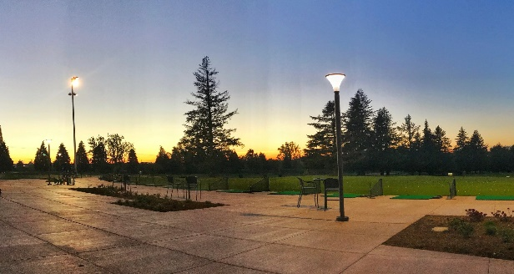

Ladies League: Mondays @ 6:00pm
Men’s League: Tuesday @ 6:00pm
Green Fees: $15 Per Week (9 Holes)
Player Name ________________________
Daytime Phone # ____________________
Email Address _______________________
League (Men’s or Ladies) ______________
Contact Tesching Professional, Jarred Gomez at (503)254-5515 or jgomez@kempersports.com with any questions or go to www.colwoodgolf.com/leagues for more information.
Colwood Golf Leagues 2019
Registration Form – Free to Join!
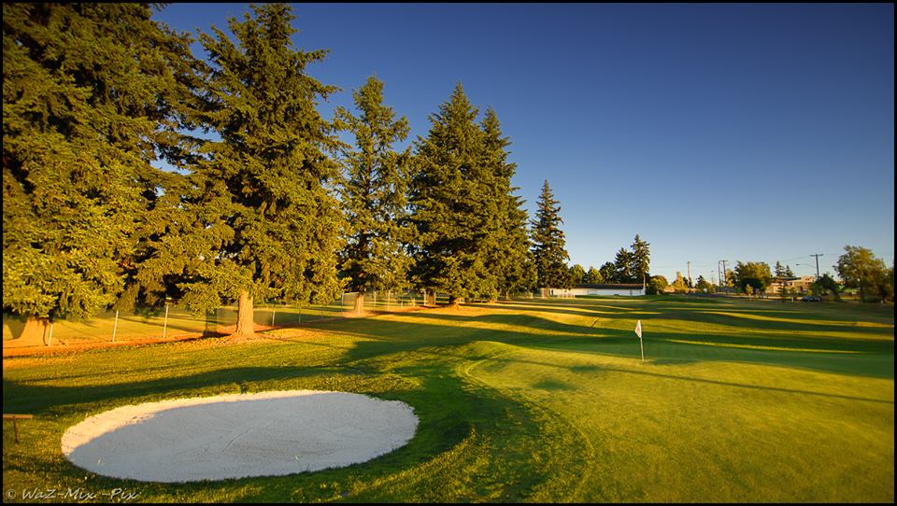
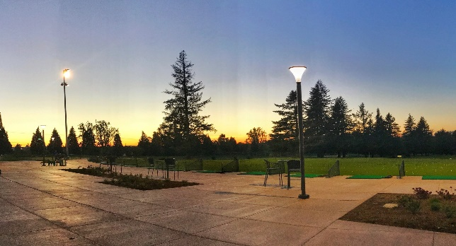

Ladies League: Mondays @ 6:00pm
Men’s League: Tuesday @ 6:00pm
Green Fees: $15 Per Week (9 Holes)
Player Name ________________________
Daytime Phone # ____________________
Email Address _______________________
League (Men’s or Ladies) ______________
Contact Teaching Professional, Jarred Gomez at (503)254-5515 or jgomez@kempersports.com with any questions or go to www.colwoodgolf.com/leagues for more information.

