
10200 Old Dominion Parkway,
Fredericksburg, VA 22408
(540) 891-0111
www.leeshillgc.com
Memberships at Lee’s Hill
Unparalleled Value for the True Golf Enthusiast – Members of Lee’s Hill Golf Club enjoy a caliber of golfing excellence that few communities can match. Our championship golf course has been crafted by Bill Love, one of the most sought-after names in golf course design. With 18 holes draped across lush Virginia forests and natural wetlands, each shot is challenging and unique.
Membership at Lee’s Hill Golf Club, which is available to both residents and non-residents of Lee’s Hill, has its distinct privileges. Full members enjoy a variety of amenities and benefits, such as complimentary green fees, special advance tee times, discounts and members only golf and social events. We invite you to contact us today at (540) 891-0111 to find out more about becoming a part of our membership family at Lee’s Hill. Cart Plan available*
Ask about discounted Initiation fees for Lee’s Hill Community Residents.
Single Membership, 7 Day
Initiation $1,500 one time, non-refundable fee ………………………...Monthly Dues $179
*Single Cart Plan: $96 per month, min of one year

Family Membership, 7 Day
Initiation $2,000 one time, non-refundable fee ………………………....Monthly Dues $209
*Family Cart Plan: $160 per month, min of one year

Weekday Single Membership (Monday – Friday)
Initiation $1,500 one time, non-refundable fee………………………..…Monthly Dues $117

Weekday Family Membership (Monday – Friday)
Initiation $2,000 one time, non-refundable fee………………………….Monthly dues $137

Lee’s Hill Membership Benefits Include:
- Complimentary greens fees
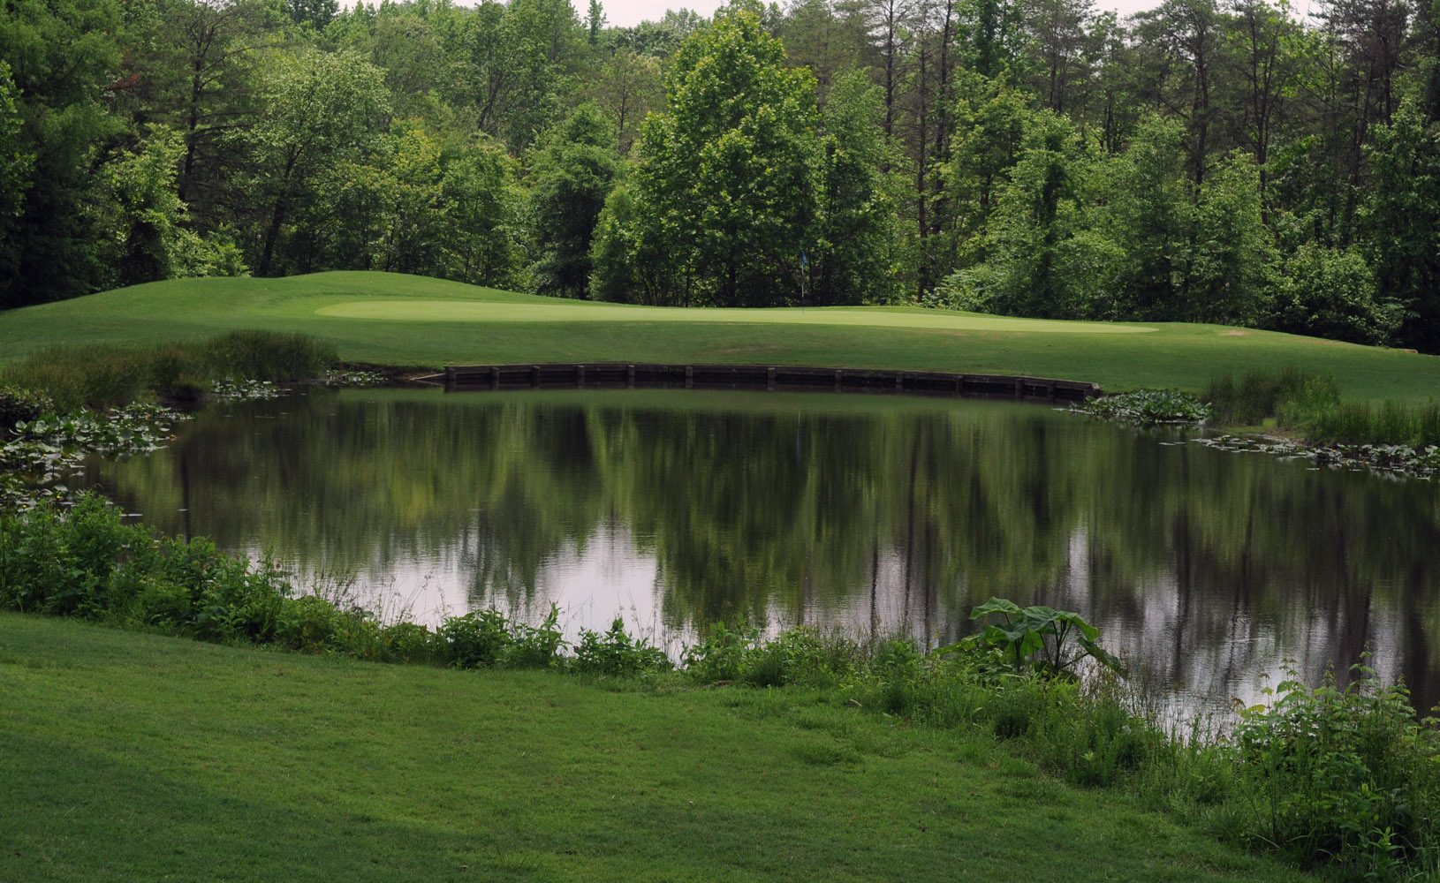
- Advanced preferred starting time
- Charging privileges for golf, food, beverage & merchandise
- Unlimited use of driving range
- Special Reduced Rates for Guests
- Member-only golf tournaments and social events
- Reduced prices on equipment and apparel
- No assessments and No Food Minimums
- Optional and exclusive use of VSGA handicaps
- Special programs for Women and Junior golfers

