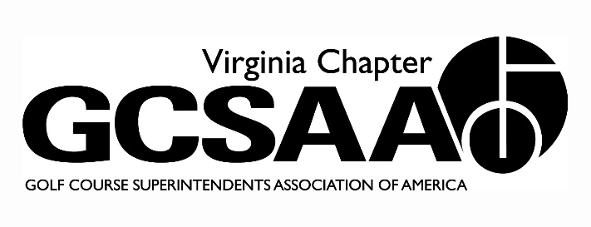
VGCSA Board Meeting: April 3, 2014
Hermitage Country club, Manikin-Sabot, VA

Attendance: David Norman, Jeff Holliday, Chris Petrelli, Mark Cote, Matt Boyce, Larry Adcock, Chad Karr, Rob Wilmans, Dan Taylor, Bill Keene, Shawn Gill
- Call To Order 10:00 am
- Investment Update—Whit Day, Northwestern Mutual
  - Move money out of Bonds into more stocks.
  - Discussion on what to do with BMP Funds currently in VTC
Desire to move to our control
Motion to move funds: Wilmans, 2nd Cote Motion approved
- Approval of Minutes
  - Motion Holliday 2nd , Petrelli
- Treasurer’s Report
  - All finances in order no major issues to report.
  - Motion Gill, 2nd Taylor
- Recap of Recent Events
  - Norman report on VA Tourism meeting and the MAPGA Banquet
  - Joint Meeting with Club Mgrs canceled.
- External VP Reports
- VTA Bill Keene report on scheduling meetings.
April meeting Derek Cataldi to speak
September meeting David McCall to speak
b. GWGCSA Shawn Gill Report on meeting schedules
Potomac Shores in September, Evergreen in November
C. ODGCSA Dan Taylor Reported March Madness was best attended ever with 70 people.
Tollie Quinn early May, different this year more prizes and fun.
d. TTA Rob Wilmans reported on successful events at hockey game and joint meeting with ODGCSA.
Hell’s Point in April
E. SVTA no report
- Fall Conferences discussion
Discussion around location and speakers.
Motion to have meeting at Hermitage and Hotel at Hilton by Jeff Holliday 2nd by Chris Petrelli. Motion approved.
Desire to have high power speakers to make a great first meeting.
Speakers to be looked at Darrin Brevard, Rhett Evans, Mike Goatley, Pat Jones or possible an Architect.
Discussion on keeping costs reasonable and possible nighttime events.
- Govt Relations, Nutrient Mgt. Planning, Economic Impact Study & Water Quality Monitoring Update
Govt Relations (Wilmans)
Discussed Nutrient Mgmt Plan Issues
Mapping and gov’t grant money.
Economic Impact Study (Norman)
Jon Guhl Interview, Trying to get Governor involved
Water Quality Management still getting inputs and volunteer sites. Starting to wrap up study.
- Partner Program Update
Partner Program
Discussion (Adcock) about value to partners and separation of levels. Also discussion on advertising and what is important to vendors.
- Rounds4Research(Gill)
Have 1 month to go. Possible letter to high profile clubs

- 2014 Committee Assignments and Reports
Assts Forum (Karr)
MAAGCS will not partner. Looking for site has a committee. Spring Creek a possibility
Awards (Keene) Dec 1 deadline okay
Communication (Petrelli) all is okay newsletter will be out by mid next week
Education (Cote) Attended VTC planning Session for next year’s show. VTC is making efforts to improve the show and education Requested education at VA Tech Field Days in August.
GCSAA (Holliday) Jeff Berg appointed to GCSAA Gov’t Relations Committee
Golf (Boyce) Saylor at Federal Club, Virlina Cup Qualifiers set
Membership (Gill) Need to get more assistant involvement, define value for assistants. Networking, education, possibly more frequent meetings for assistants
Survey (Gill) good information and feedback regarding meetings and local associations.

- Adjourn. 1:55 meeting adjourned.

