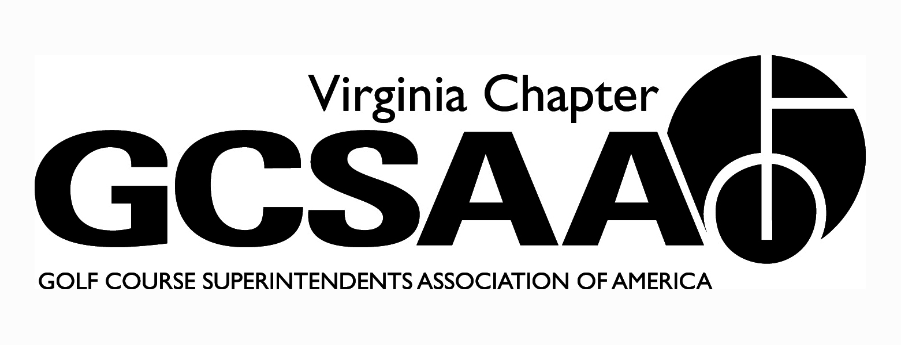

VGCSA Board Meeting
Hermitage Country Club, Manakin-Sabot, VA
August 11, 2015
10:00 Am Start

Minutes
In attendance: D. Norman, T. Eastham, J. Holliday, M. Cote, D. Taylor, S. Cornwall, S. Gill, S. Baskette, R. Johnson, D. McCall, T. Adams

Call to Order – Welcome David McCall, Turf Educator & Tyler Eastham, new N&A Associate Tyler Eastham

- Approval of Minutes - Gill Motion, Cornwell Second – minutes approved

- Treasurer’s Report (Cote) - Reminder of two Annual Meetings this year and only one budgeted. Baskette Motion, Taylor Second – report approved

- External VP Reports

GWCSA (Gill) - Good turnout More assistants and superintendents this year.

ODGCSA (Taylor) - Tollie Quinn a good event this year. Looking at more event sponsorships.

SVTA - (Cornwell) - Small turnout at Shenvalee for Dr Ervin, looking to get more superintendents involved in association.

VTA (Baskette) - Great Fundraiser this year over $3,000 for scholarship, good year overall for meetings

TTA (Holliday for Stephens) - Effects of weather vary through region, Dick Cake went well.

- Recap of Recent Events – Joint Meeting; VGCSA Championship; Environmental Cup (Presenting Sponsor update); Other
Joint Meeting - Went well at Keswick Panel with McDonough, Holliday and Graham on renovations.
VGCSA Championship at Glenmore all went well, Yancey won by six.
Environmental Cup - Good turnout –Raised $17,000. Changing sponsorship next year, need a new title sponsor. Looking at changing time frame.

- Fall Conference – speaker update, Annual Meeting, awards, 2016 options
Fall Conference filling out speakers - Barajas, Seth Jones, Panel from VA Tech and environmental panel.

- Government Relations - Nutrient Mgt. Plan Status & Grants, Water Reporting, WOTUS & VAC meeting this week, Ambassadors Program
Gov’t Relations (Gill) - discussion on WOTUS and Ambassador program, Holliday wants to send WQM study to Senators/legislators.

- Mid-Atlantic BMP project (Holliday) - Request by Mid Atlantic to use our BMP as template for theirs. Consensus seems to be ok so long as it is guideline only, desire to focus on Virginia issues and superintendents. There were further discussions regarding relationship with Mid Atlantic.

- Partner Program Update - Suggestion by Adams to focus on manufacturers as the distributers have tighter budgets and less to spread around.

- GCSAA Update - Rounds4Research, Chapter Outreach Grant (US Open ads), DSA nominations due Aug. 31

R4R (Gill) - Numbers have declined a lot. Timing of auctions discussed. Success comes from big names participating. Need to balance relationship with GCSAA.

Chapter Outreach (Holliday) - $3,000 for ad campaign, “Thank a Superintendent”
DSA award. Need to get ball moving to announce awards at annual meeting

- Buy Sod Scholarship – winner, policy, “endowment” fund. Discussion on how much and how many scholarships to give, no action taken

- Event Previews - Virlina Cup, Assistants Forum (Joint with MAAGCS), 2016 GCSAA Social Event
Assistants Forum - To be at Belmont CC with Tim Moraghan, working on a Panel.

- Miscellaneous Committee Reports –
Communications - (Facebook policy, weekly emails), Membership, Research (McCall proposal)

Membership - need to attract more members, focus on Assistants as source.

Survey - Looking to add new elements regarding education

Facebook - Discussion on who uses and what policy should be. No commercial content and must be a member or Partner to use.

Research - Discussion on BMP dollars and what type of research to sponsor. Conversation on number of assistant candidates coming out of Tech and any way to help that. D. McCall to put together a Research Proposal.

- Office of Vice President – replacing Petrelli
Motion to move Cote to VP position - Baskette Motion, Gill Second, Approved. Need to get new Sec/Treasurer, discussion on potential candidates. Externals to vote on candidate to be presented at Annual Meeting.

- Old Business / New Business
Potential to add an Assistants event in spring

- Executive Session

- Adjourn 2:07 pm

