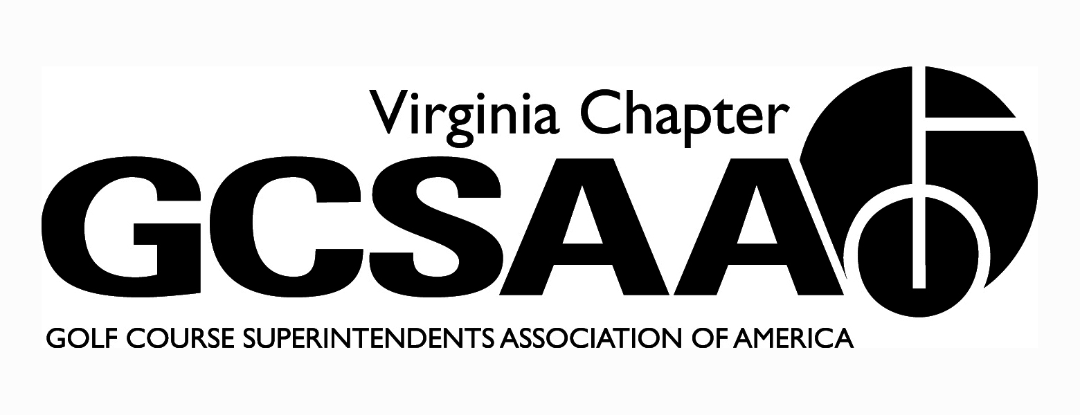

VGCSA Board Meeting
Hermitage Country Club, Manakin-Sabot, VA
February 12, 2015
10:00 Am Start

Agenda

Call to Order - Holliday at 10 a.m.
Present D. Norman, J. Holiday, C Petrelli, D Taylor, T Adams, S.Cornwell, R Johnson, S. Gill, S. Baskette, P. Stevens, M Cote

- Introduction of New Board Members

- Approval of Minutes
Gill motion, Baskette 2nd

- Treasurer’s Report
Cote- No major issues to discuss, all in order, Petrelli motion, Taylor 2nd

- Government Relations (legislative visit), Nutrient Mgt. Planning, DEQ Water Reporting
Holiday – Legislative visit went well, all were introduced on floor and mention made of environmental and economic impacts.
NMP- new grants out $149,000 available to whole state
DEQ Water Reporting - push in 2015 for awareness of rules of reporting and permitting

- Promoting the Profession – Chapter Outreach Program Ad (May issue, Virginia Golfer)
Chapter Outreach Holliday- Va. Golfer issue on conserving water and how to get word out of Superintendents good work in this direction

- External VP Reports
ODGCSA- Taylor
New officers coming on board, Jay Wade. Kevin Fortune president
Going to less meetings has been better
Members very supportive of VGCSA Meeting in Fall

SVTA- Cornwell
All events scheduled,
Due to fewer assistants will focus on research rather than straight donation to Asst Forum

VTA- Baskette
New board members brought on board
Spurlock as industry rep
Schedule of meetings set

TTA- Stevens
Reducing meetings
Some meetings will be free
Rob Wilmans on board
Holliday- Push ways to increase meeting attendance, revive the concept of the industry as a “fraternity”, phone trees, ride sharing, keep costs low

- Recap of Recent Events –Virginia Golf Council Meeting, Annual Meeting, VTC Conference
Va. Golf Council – Gill - enjoyed going to meeting to see all aspects and that all are trying to grow golf.

Annual Meeting- Holliday- all went well, awards recipients great choices, scholarship winner appreciative and overall good turnout

VTC Conference- Holliday
Discussion on classes, mostly positive, trade show okay—mostly a networking event versus any purchases made
Further discussion regarding VTC and VGCSA potential move to October Meeting. Agree to do it but to keep at two days including golf.
Communication with VTC and Rick Owens to continue during process.
VGCSA meeting is consistent with our bylaws and mission statement.
Must build slowly onto good meetings we’ve had in the past.

- Partner Program Update

- Research – R4R 2015; Grant Request from Dr. Ervin
Research proposal by Dr Ervin discussed re: traffic on Burmudagrass. Concerns raised over purchase of utility cart to use during research.

- Updates of BMP Manual
DEQ offered some updates and clarifications, discussion on how and when to update Manual.
Holiday- Possibility of having board advisory position from Va Tech, Baskette motion, Taylor 2nd motion passed to invite Dr Goately to serve on Board

- Use of VGCSA Logo
Motion Petrelli, 2nd Adams to allow use of Logo by members and partners

- 2015 Committee Assignments & Reports
Assistants Forum - Johnson- possibly at Kanawa club, wants to grow numbers, possible partner with MAAGCS when Northern Va event
Petrelli to go to Delegate meeting
Cote to attend Leadership meeting with Norman

- 2015 VGCSA Fall Conference & Joe Saylor Tournament
Norman – need to decide now, keep at Hermitage and have Annual meeting after golf then hold conference next day.
Need to have great speakers, and build on previous success.

- Other Events - VGCSA Championship & Virlina Cup, VGCSA-CMAA-NGCOA Joint Meetings, Assistants Forum, GCSAA Chapter Leaders

- Old Business / New Business – Board position for VT

- Executive Session

- Adjourn 2:16 PM

