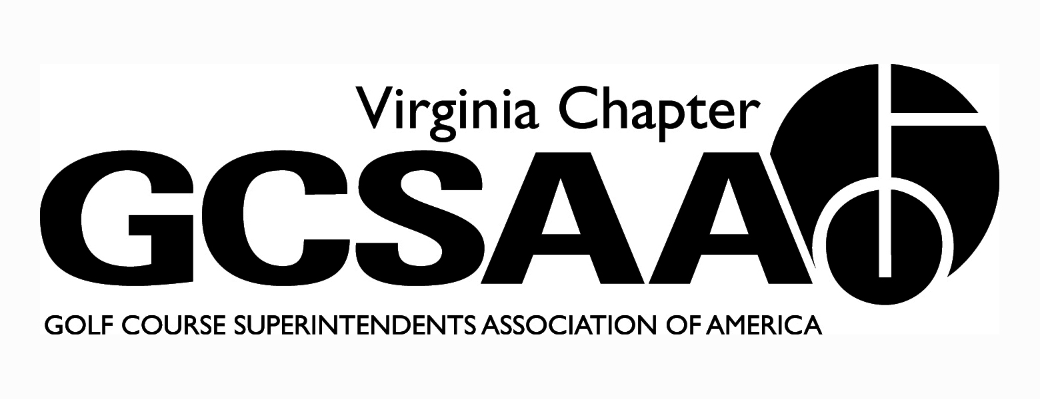

VGCSA Board Meeting Minutes
Hermitage Country Club, Manakin-Sabot, VA
April 14, 2016

In attendance: D. Norman, T. Eastham, J. Holliday, M. Cote, B. Keene, S. Baskette, B. McCurry, S. Mauldin, P. Stephens, D. McCall, S. Gill, J. Wade

Call to Order - 10:03

- Approval of Minutes – Motion Baskette, Second McCurry– minutes approved

- Treasurer’s Report (Keene) – Finances in good standings. Members are paying dues on time. Better pricing on GCSAA social. Baskette Motion, Gill Second – report approved

- Partner Update - Program remains level. Some have dropped like architects, and others moved up a level. First year with no growth of program.

- External VP Report

SVTA - First meeting was at Bowling Green on 3/17 and next meeting at Heritage Oaks

VTA -First meeting at Cinebowl with VT students, fundraiser at Hidden Valley in May, June at Falling River CC in Appomattox, Summer baseball game, August at Primland, October at Roanoke CC. Vendor program to kick off now.

ODGCSA - Tollie Quinn now scholarship tourney, hope to have 75 participants. March madness was good with Jacobsen picking up tab. No meetings in June and July and finish up the year at Kanawha.

TTA - Dr. Yelverton will be at their meeting at Elizabeth Manor. The Dick Cake is at Cedar Point and they end the year at ICYCC in October.

GWGCSA – first event coming up, working on schedule; looking at MAAGCS Match Play as a possible event for VGCSA

- Event Review

Legislative Visit - 2/18/16. The visits were better with more people attending. Most took the free gift, some declined. We received a letter from the governor for our visit. We should invite a group to the environmental cup.

Joint Meeting (Holliday) - Good meeting with good information for supers. GM’s from Chevy Chase, Baltimore CC and Wilmington CC (DE) spoke. Princess Anne’s GM spoke highly of the jobs we do. Clubs need to think outside the norm to continue being successful.

Chapter Leaders Meeting (Cote) - GCSAA is embracing the new mechanics portion of the membership. We need to continue to grow the ambassadors program and rounds for research. VGCSA is highly thought of at national. Ohio has 5 associations and are difficult to work with. Meeting attendance is a struggle everywhere, there is no silver bullet. Eastham mentioned specialty meetings held by other chapters (e.g., Christmas Party)

- 2016 Event Schedule

VGCSA Championship - 5/9 at Boonsboro CC. Vendor flight and a net division. Syngenta to sponsor, $40 entry fee

Environmental Cup - Keswick on 6/13. Helena is title sponsor with less other sponsors because LSI could pull advertising dollars from others to make additional sponsors. $150pp

Joe Saylor- 10/20 at Fawn Lake in Fredericksburg area

Virlina Cup- Belle Haven CC on October 23-25

Assistants Forum - Independence GC date TBD because of Sr. PGA event in town. Price and speaker forthcoming.

MATE - 1/28-2/2 week before national in Orlando. Lots of unknowns from 2016, i.e., attendance and registration numbers, revenue, and monies collected by each University. Talks of combining the fundraising tourneys with it under the umbrella of a VT fundraiser. Some question where money from both tourneys go, this would answer it.

- Assistant and Student recruitment (DM) - Many are pointing to the lack of superintendent jobs as a reason for low numbers, coupled with long hours, not appealing to many. Many of best options are guys already in workforce. How do we educate these people? Certificate programs, online schooling, local community college. Get them exposed early by tapping FFA, First Tee programs, and high school golf teams. Investigate using GCSAA chapter outreach money to produce a video to recruit. Show technology and “cool side” of business.

- Conference Education Planning - Monday have a roundtable with real time question and answer where we can use cell phone to vote on topics and have instant answers. Names being kicked around were, Dave Oatis USGA, Frank Wong, Bayer, John Zimmers and Ken Ingrum.

- Committee Reports

Survey (PS) - Overall score was a B. Only 88 participants, may need to look into incentivizing participation

Research (DM) - Everyone has trials out, results forthcoming.

Rounds for Research - Need to work on advertising. Hopefully date change will drive more traffic.

- Old/new Business - S. Gill spoke about update to pollinator protection coming from the state.

- Adjourn 1:16 pm

