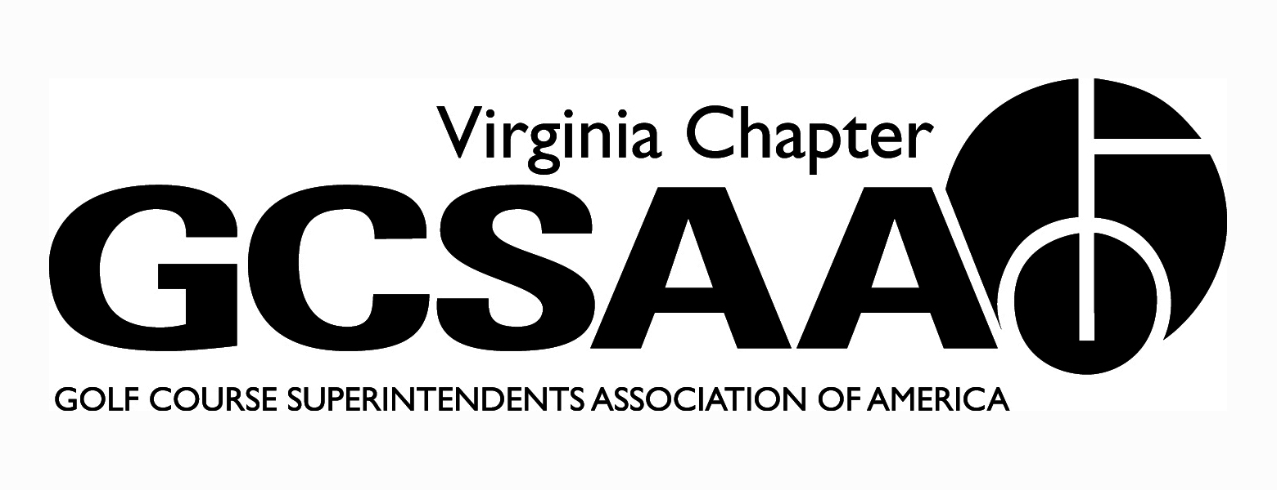
VGCSA board meeting: April 18, 2013 at 10 AM
Location: VGCSA office, Glen Allen, VA
Attendance: David Norman, Matt Boyce, Jeff Holliday CGCS, Chris Petrelli, Dan Taylor CGCS, Rob Wilmans, Bill Keene, Aaron Evans, Steve Dorer.
- Call to order at 10:04 AM (Boyce)
- Approval of previous meeting minutes:
- Motion: Wilmans, second: Dorer
- Treasurer Report: (Petrelli)
- Dues are up due to earlier payments and dues increase that was approved for 2013.
- Discussed credit card fees since more are paying this way, no change approved.
- Motion to approve report: Dorer, second: Taylor
- Partner Program: (Norman)
- Currently up 5 percent, fewer accounts need to pay.
- All Diamond partners have renewed and Bronze pricing has been increased
- Discussion on how we continue to grow the program. VGCSA is an excellent value because of the special treatment David provides (Dorer). Prices have not increased since 2006 (Norman). Is it possible to reduce our costs for events if we were to expand the partner program (Holliday)?
- Discussion on taking the newsletter electronic. No action taken.
- Recap of Recent Events:
- Chapter Leaders (Holliday): A great event, excellent roundtable. GCSAA wants to implement some type of member outreach to new members in your area. Mid-Atlantic field representative is being hired although the VGCSA is a good organization and may not need field rep as much.
- Government Relations ( Wilmans) :
- Water Quality Monitoring (Wilmans): No update. Boyce will reach out to Chantel and Dr. Ervin and see how we can help.
- Landscape Supply BMP Fundraiser (Norman): Sponsorships are on par with last year
- Nutrient Management Planning: Must continue to promote this program. Possibly promote in newsletter and annual meeting who has their NMP certification (Dorer).
- Meeting with Donna Johnson (Boyce): There continues to be a need for a quarterback for the government relations committee. Donna is not interested in a full time role, believes the VAC can achieve our goals. Katie Frazier will attend VGCSA meetings and give an update on important issues. Katie willing to do a Government relations 101 type course for the committee. Need someone to identify what meetings we need representation at and make sure someone attends (Wilmans).
- External VP’s Reports:
- GWGCSA: (Gill):
- Meeting schedule is not finalized, Superintendent/Pro event next week.
- TTA: (Wilmans):
- Good meeting with psychologist and joint meeting
- Dick Cake May 20th for Virlina Cup qualifier
- ODGCSA: (Taylor)
- March 12th Joint meeting with TTA went well, March Madness also went well.
- Tollie Quinn is May 7th at Williamsburg Club, 2 man Best Ball
- VTA(Keene)
- First event this week, good turnout around 30 people. Going to go with mostly non-turf speakers this year.
- Fundraiser May 21st at Hidden Valley
- SVTA(not present)

- Rounds for Research (Dorer and Norman):
- Need to email top clubs in attempt to recruit donations, need this by April 30th. Big name clubs will drive signups.
- Committee reports:
- Assistants (Evans): Assistant’s Forum is going to Independence GC, still looking for speakers, possibly Bruce Williams.
- Awards (Keene): Only 2 applications for Buy Sod scholarship, externals will review the essays. Buy sod will be ex-officio on this. Motion: Taylor, second: Wilmans.
- Communications (Holliday): Working on directory, publish early May
- Education (Boyce): Need to have participation in VTC education planning meeting on May 1 or 2. Holliday may attend. Lewallen wants to push Nutrient Management and Water Monitoring for ODGCSA education at VTC Conference
- Golf (Boyce): So far, 28 have signed up for VGCSA Championship at Foundry. Wee One planning meeting on April 30th.
- Government Relations (Wilmans): will attend Agribusiness Council Golf with legislator.
- Membership (Boyce): Dues numbers have increased dues increase didn’t seem to have an effect.
- Nominations (Wilmans): Seeking Secretary/Treasurer in November.

- 2013 Events (Norman):
- Joint meeting at Princess Anne on June 10th with the VGCSA, CMAA and NCGOA with Billy Fuller as speaker, Horizon is sponsor.
- Naming Scholarship and Awards:
- Discussion of naming of Distinguished Service and Scholarship winner. No action taken.
- Annual Conference Event:
- Discussion of Education with Joe Saylor: Motion to do fall conference in conjunction with Joe Saylor in 2014: Motion: Wilmans, second: Taylor

- Old/New Business: GCSAA has asked for VGCSA to help promote Rounds for Research
- Meeting adjourned at 12:51, motion: Holliday, second: Dorer.
Respectfully Submitted,
Chris Petrelli
Secretary/Treasurer

