A Novel Method to Facilitate Biodethatching Using Fungal Laccases
February, 2010
Sudeep Sidhu, Qingguo Huang
Department of Crop & Soil Sciences, University of Georgia, Griffin

Introduction
The proposed research was designed to explore the feasibility of utilizing extracellular laccases produced by white rot fungi to enhance the biodegradability of thatch. Through the study, we intend to develop the enzymatic pretreatment method that will significantly enhance the effectiveness of the bio-dethatching processes.
Thatch is a layer of organic matter consisting of tightly intermingled dead and living leaves stem and roots that develop between the soil surface and the green vegetation. Thatch layer intermixed with sand or soil is known as Mat layer (Beard 1973). High organic matter accumulation in form of thatch or mat causes depletion of oxygen and decreased saturated hydraulic conductivity and increased water content (Hartwiger 2004). This further leads to problems like welt wilt, soft surface, black layer, limited rooting etc. (Carrow 2004; O’Brien and Hartwiger 2003).
Lignin, a 3- dimensional amorphous polymer consisting of methoxylated phenyl propane structure limits the degradation of organic matter (Beard 1973). It resists most microbial degradation mechanisms and serves as a barrier in the cell walls to limit the accessibility to the more biodegradable plant materials, such as cellulose and hemicelluloses, by microbial degraders. Oxidative enzymes such as laccases, lignin peroxidases and manganese peroxidases produced by white rot fungi attack the aromatic components of lignin and leads to its effective degradation.
White rot fungi are recognized as the most active lignin degrading microorganisms among few in the nature (Boyle, et al 1992; Gold and Alic 1993). Oxidative enzymes produced by fungi are able to attack the aromatic contents in lignin and produce free radicals, leading to effective degradation of lignin (Nakayamaa and Kamachi 1999). We hypothesize that thatch that has been directly treated with lignin-degrading enzymes will be more amenable for microbial degradation because the lignin barrier that restricts the microbial accessibility have been effectively removed.
Laccases, lignin peroxidases, and manganese peroxidases are enzymes that have been known to be involved in lignin degradation (Nakayamaa and Kamachi 1999). They have been widely studied and used in pulp and paper industry to remove lignin, which serves as strong basis supporting the hypothesis mentioned above. Laccases, the multi copper oxidases are known to act on a wide variety of aromatic compounds by reducing oxygen to water (Baldrian 2006). The capability of degrading lignin utilizing oxygen as well as their strong extracellular activity makes laccases potentially suitable material for bio dethatching.
The proposed research is aimed at verifying the following hypothesis: 1) degradation of organic matter can be enhanced by applying laccase to the thatch layer; and 2) laccase has no appreciable adverse effects on turf quality.
OBJECTIVES
To test the hypothesis listed above represents the overarching goal of this study, and this will be achieved in a three phase studies. Phase 1 was a laboratory study aimed to verify the ability of laccase to facilitate the degradation of the organic matter in thatch layer; Phase 2 is a green house study with bentgrass pots to determine the effects of laccase application on thatch layer and on turf quality; Phase 3 will be a field study to evaluate the overall dethatching effect under field conditions.
Progress
Phase One:
Thatch was collected from the bentgrass pots in greenhouse at Griffin, GA. Thatch was cut into five by five cm squares and air dried. Dried thatch was ground with the coffee grinder and was passed through the 20- mesh sieve at the top and 80- mesh sieve at the bottom. The sieves were shaken for 15 minutes. The material left on the top of 20- mesh was reprocessed and material below 80- mesh was discarded. The material retained on 80- mesh was retained and used for analysis.
A 300 mg portion of thatch was weighed in each of 18 Petri plates. Ten ml of six different levels of laccase 0 (control), 2, 4, 6, 8 and 10 units/ml was added to Petri plates everyday as triplicates for seven days. I unit activity of laccase equals the amount of enzyme that causes the absorbance change in 468 nm at a rate of 1.0 unit/ min in 3.4 ml of I mM 2,6-dimethoxyphenol in citrate-phosphate buffer at pH3.8 (Park et al., 1999).
The thatch was extracted using Soxhlet method with water for water soluble impurities and with ethyl alcohol for alcohol soluble impurities using. A 200 ml portion of HPLC grade water was added to the receiving flask, and the thatch samples were placed in the thimble. The heating mantles were adjusted to four to five siphon cycles per hour. Extraction with water was continued for 24 hours. The thimble was left in the Soxhlet apparatus and water in the receiving flask was changed with 95 percent USP grade ethyl alcohol. The heating mantles were adjusted for six to ten siphon cycles per hour. Extraction with ethyl alcohol was continued for 24 hours. After extraction, the heating mantes were stopped and the glassware was allowed to cool. The thatch samples were removed as quantitatively as possible onto cellulose filter paper. Thatch was washed with HPLC grade water. Thatch was air dried to moisture content less than 10 percent.
An appropriate number of filtering crucibles were placed in the muffle furnace at 575 ± 25⁰C for minimum of four hours. Crucibles were transferred from muffle furnace to desiccator for at least one hour and then were weighed on analytical balance to the nearest 0.1 mg. Crucibles were placed back in the muffle furnace at 575 ± 25⁰C and ashed to constant weight (defined as less than ±0.3 mg change in weight upon one hour of reheating the crucibles).
A 100±10.0 mg portion of the sample was collected in pressure tubes. A 1.00 ± 0.01 ml of 72 % sulfuric acid was added in each pressure tube containing sample and was stirred with Teflon rod. Pressure tubes were placed then water bath 30 ± 3⁰C for one hour. At the same time the sample was analyzed for moisture percent. The sample in the tubes was mixed on regular basis at every five to ten min without removing the tubes from water bath. After removing the tubes from water bath, acid in the tubes were diluted to four percent by adding 27.88±0.04 ml deionized water using an automatic burette. Teflon caps were screwed tightly and then tube was inverted several times for eliminating phase separation between high and low concentration acid layers Tubes were placed in an autoclave safe rack autoclave for one hour at 121⁰C. After autoclaving, tubes were allowed to cool down at room temperature.
Autoclaved hydrolysis solutions were vacuum filtered through one of the previously weighed filtering crucibles in filtering flask. An aliquot was transferred in a 50 ml storage bottle for determining acid soluble lignin. The absorbance of the aliquot was measured using a UV/Vis spectrophotometer at 240 and 320nm. The sample was diluted with deionized water to have the absorbance reading in the range of 0.7 to 1.0.
The entire remaining solid (acid insoluble residue) was transferred out of the pressure tube using deionized water. Filtering crucibles containing acid insoluble residue were placed in the oven at 105 ± 3⁰C until a constant weight was achieved usually a minimum of 4 hours. Samples were then removed from oven and cooled in desiccator. Weigh the crucibles and dry residue up to ± 0.1 mg. Crucibles and residue were placed in muffle furnace at 575 ± 25⁰C for 24 ± 6 hours. Crucibles were then removed carefully from the muffle furnace, and were placed directly into the desiccators for cooling down to room temperature (1-2 hours).Crucibles and ash were weighed to the nearest ± 0.1 mg and were placed back in muffle furnace to a constant weight.
Where is the protein content present in the acid insoluble residue.
Is the oven dry weight of the sample.

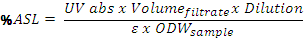
Where ε is the absorptivity of biomass at specific wavelength.
Phase 2:
Phase 2 was a greenhouse study started in October 2008. Bentgrass together with 20 cm depth under layer material was sampled from a turf field with significant thatch/ mat accumulation and put in 6 inch pots to grow in a green house (25± 2/ 18 ±2 ºC, day/ night) at UGA Griffin campus. All the pots were irrigated with 40 ml water every day and fertilized monthly. Laccase is sprayed every two weeks through irrigation water at activity 0, 0.04, 0.4 and 4 units /ml, respectively. The pots irrigated with distilled water containing 0 units/ ml served as controls. The pots receiving 0.04, 0.4 and 4 units /ml were further divided into two groups, one which received guaiacol along with laccase. Guaiacol is mediator of laccase which is believed to enhance enzyme performance. For all the treatments, twelve replicates were prepared, five of which were sampled during December 2008, about two months of treatment. For the treatment 4 units /ml the samples were only taken during December 2008.
Physiological performance of each treatment was routinely analyzed by rating turf quality and canopy reflectance. The turf quality was rated on the basis of color, shoots density and uniformity of stand and is given a numerical score, where 1 equals no live turf and 9 equals ideal dark green, uniform grass. Grass index was measured using TCM 500 turf color meter (Spectrum Technologies Inc.). Grass index is based in the color and density of the grass. Canopy reflectance was collected between 400 and 1100 nm wavelengths at 3 nm intervals with a Unispec Spectral Analysis System (PP system , Haverhil, MA). Normalized difference vegetation index (NDVI) is calculated by using canopy reflectance formula (R750-R705) / (R750+R705); with higher value indicating a better green cover.
Thatch layer thickness, organic matter content, lignin content and saturated hydraulic conductivity were measured once during December 2008 for five replications and were measured at the completion of treatments during September 2009 for the remaining replications. Saturated hydraulic conductivity (K_{sat}) of prepared root zone mixes was measured by a constant head using a Marriott tube. Four replications of the root zone mixes were hand packed into the plastic tube of diameter 4.7 cm. The packed soil cores were covered by cheese cloth on the bottom and placed in 0.05 N CaCl₂ solution overnight to remove the trapped air in the soil pores. The reservoir of the Marriott tube was filled with 0.05 N CaCl₂ solution and the top of the tube was covered with rubber stopper with two glass tubes fitted in it. One glass tube is used to for water flow and other for air inlet. Once, the soil columns were saturated, they were connected to another hollow plastic tube of the same diameter using parafilm sheet to avoid water leakage. Water is allowed to stand above the soil core and the difference between the height of bottom of the glass tube and the soil core is used to maintain a constant head. Water for the first ten minutes was discarded. Water was allowed to flow for twelve minutes with sub sampling time of three minutes. Two sod plugs, 2.0 cm in diameter, was randomly taken from each pot from five replications, using a golf course cup cutter and used in the determination of organic matter. The thatch portion was oven dried at 105 ºC for 48 hours, weighed and then ashed at 600 ºC for 24 hours. Percent organic matter is determined as difference between dry weight and ash weight. Acid soluble and acid insoluble lignin content was determined in the same way mentioned in the previous report for phase 1 study. Organic layer thickness was measured from the edges of the pot with seven replications per pot and then averaging it.

RESULTS
Lab Study
There was a significant decrease in the acid-soluble lignin content with increasing levels of laccase activity. There was a 20.5 percent decrease in acid soluble lignin in thatch sample treated with 10 units/ml of enzyme as compared with the control. Acid-insoluble lignin and total lignin content decreased significantly with increasing levels of enzyme activity up to 6 units/ml activity of laccase. Acid-insoluble lignin and total lignin content decreased by 18.5 and 26.6 percent, respectively as compared to control.
Greenhouse Study
Quality Measurements: Visual quality ratings, grass index and canopy reflectance data was not significantly different with different level of enzyme activity application. Different quality measurements showed that there was no adverse effect on enzyme application on bentgrass.
Total Organic carbon: There was no significant reduction in total organic carbon after two months of enzyme application. However, after nine months of treatment a significant 32.1 percent reduction in total organic content for the upper 2.5 cm was observed at the treatment level of 0.4 units/ml enzyme activity as compared to the control. The treatment 0.4 unit/ml enzyme activity with or without mediator is showing significant differences at 1% level of significance as compared to control as well 0.04 units/ml enzyme activity for total organic carbon. Total organic carbon content in the lower 2.5 cm was not significantly different.
Thatch Layer Thickness: Total organic layer was measured instead of thatch layer after two months of the treatment due to the presence of inconspicuous thatch layer. There were no significant differences observed. After nine months of treatment a 45 percent decrease in thatch layer thickness was observed with 0.4 units/ml enzyme treatment as compared to control.
Saturated Hydraulic Conductivity: Saturated hydraulic conductivity measurements were conducted after nine months of enzymatic treatments. Saturated hydraulic conductivity for 0.4 units/ml treatment with and without guaiacol was significantly higher than control. Saturated hydraulic conductivity for control and 0.04 units/ml enzyme activity treatment are 6.7 and 13.0 cm/hr, respectively.
Lignin Content: After two months of enzymatic treatments, significant reduction of 11.9 and 8.6 percent in both acid-soluble and -insoluble lignin content respectively was observed at treatment level 4 units /ml as compared to control. The lignin content at 0.04 units/ml as well as 0.4 units/ml treatments were significantly similar to the control. However, after nine months of treatment a significant 12.3 and 7.4 percent reduction in both acid-soluble and -insoluble lignin, respectively was observed at 0.04 units/ml enzyme activity.

Results after two months of Treatment
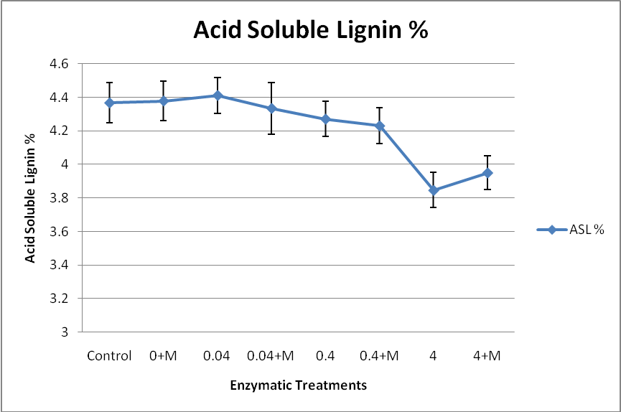

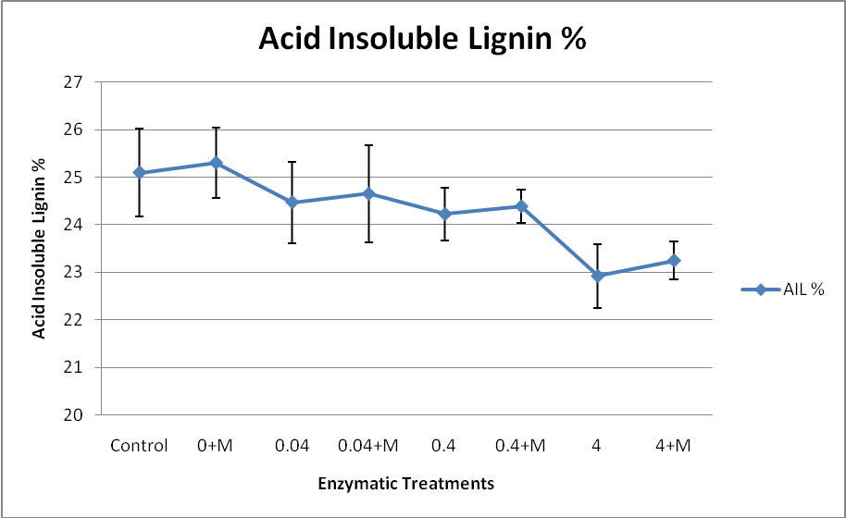

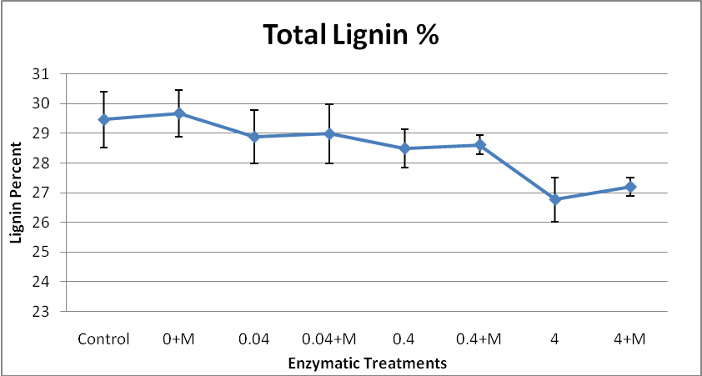

Results after nine months of enzyme treatments

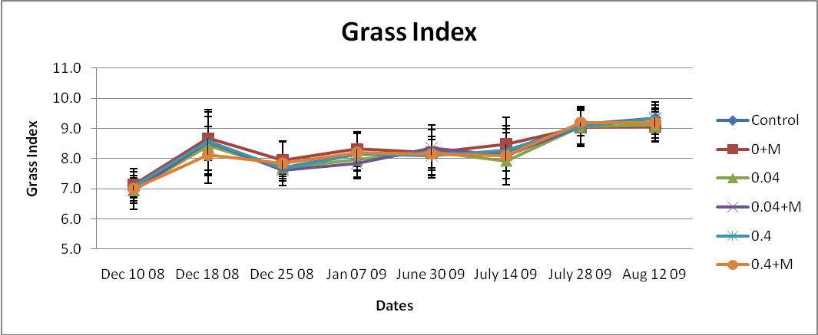

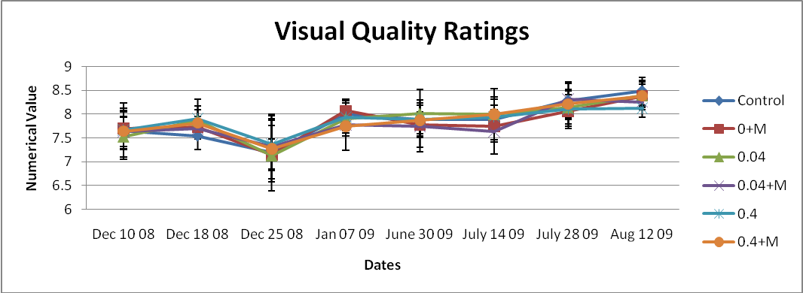

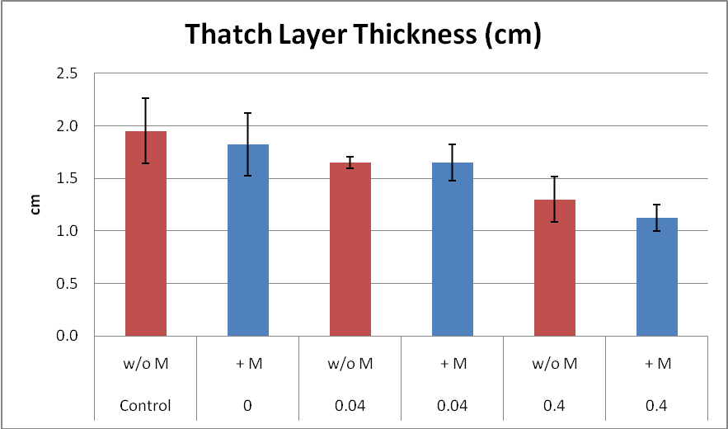
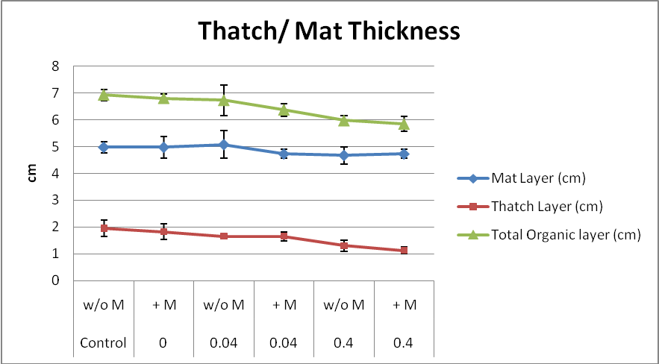

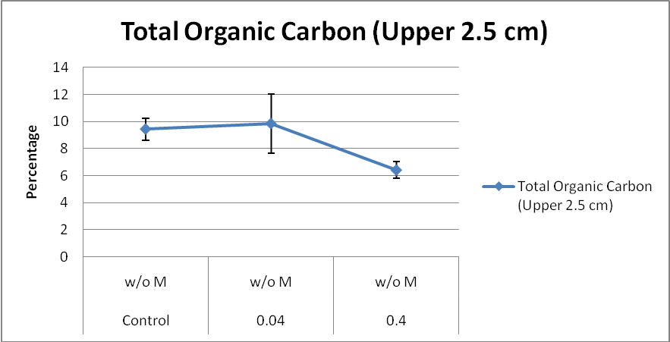

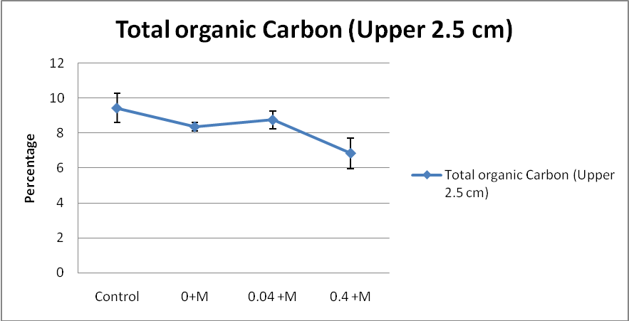

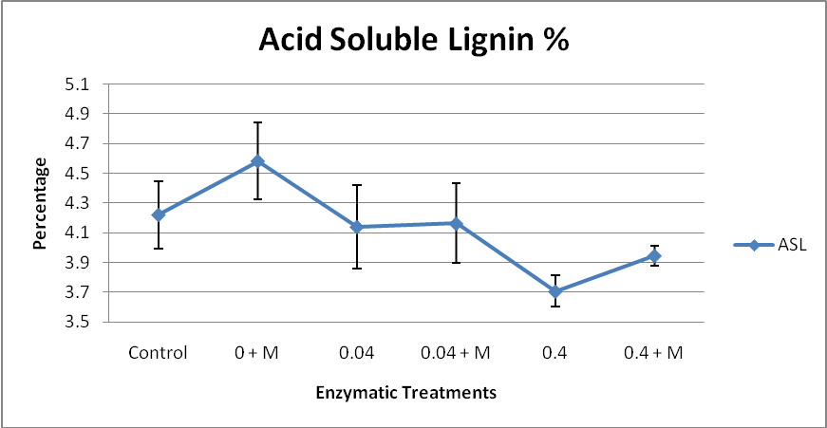
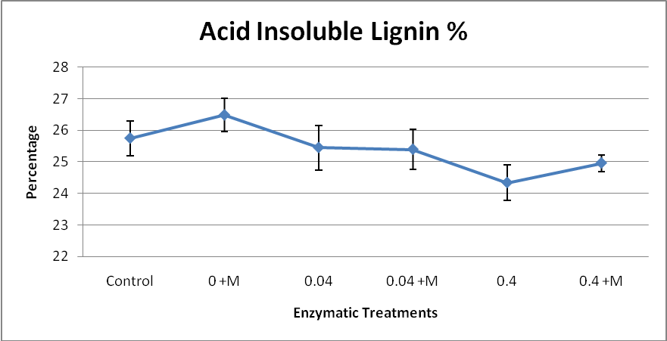
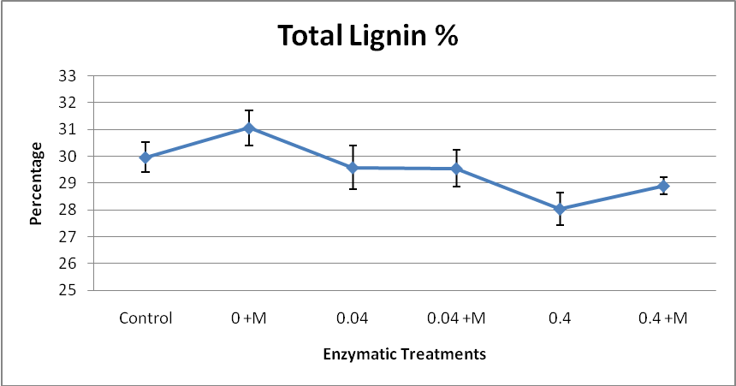
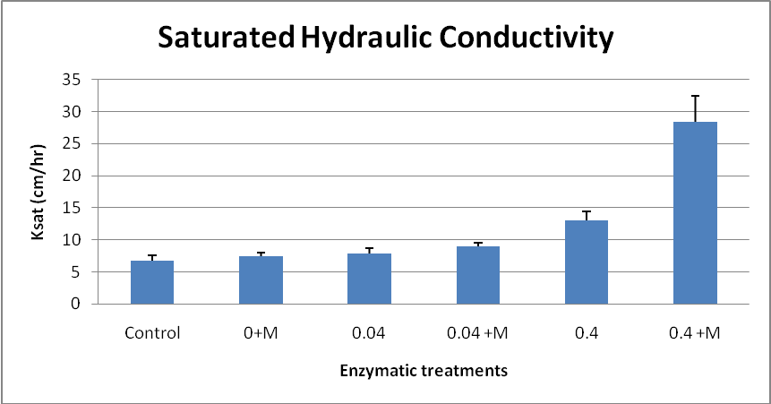

REFERENCES
Beard, J.B. 1973. Turfgrass: Science and culture. Prentice Hall Inc. Englewood Cliffs, NJ.
Hartwiger, C. 2004. The importance of organic matter dynamics: How research uncovered the primary cause of secondary problems. USGA Green Section Record 42(3): 9-11.
Carrow, R.N. 2004. Surface organic matter in bentgrass greens. Golf Course Mgt. 72(5): 96-101.
O’Brien, P., and C. Hartwiger. 2003. Aeration and topdressing for the 21st centuary: Two old concepts are linked together to offer up-to-date recommendations. USGA Green Section Record 41(2): 1-7.
Boyle, C. D, B. R. Kropp and I. D. Reid. 1992. Solubilization and mineralization of lignin by white rot fungi. Applied and Environmental Microbiology 58 (3): 3217-3224.
Gold, M. H. and M. Alic. 1993. Molecular biology of lignin-degrading basidiomycete phanerochaete chryosporium. Microbiology and Molecular biology reviews. 57(3): 605-622.
Nakayama T. and T. Amachi. 1999. Fungal peroxidases: its structure, function and application. Journal of Molecular catalysisB: Enzymatic. 6(3): 185-198.
Baldrian, P. 2006. Fungal Laccases- occurance and properties. FEMS Microbiol. Rev. 30: 215 -242.

